~LIVESTREAMED TO FACEBOOK~
We are live streaming today’s worship service on Facebook, so we want you to know that your presence here today is your agreement and consent to being part of that recording.

~Please continue wearing your mask while in the Sanctuary~
~Please whisper or mouth words during responsive reading~
~Please remain seated and enjoy listening to the music~
~Offering plates will be located at the back of the Sanctuary~

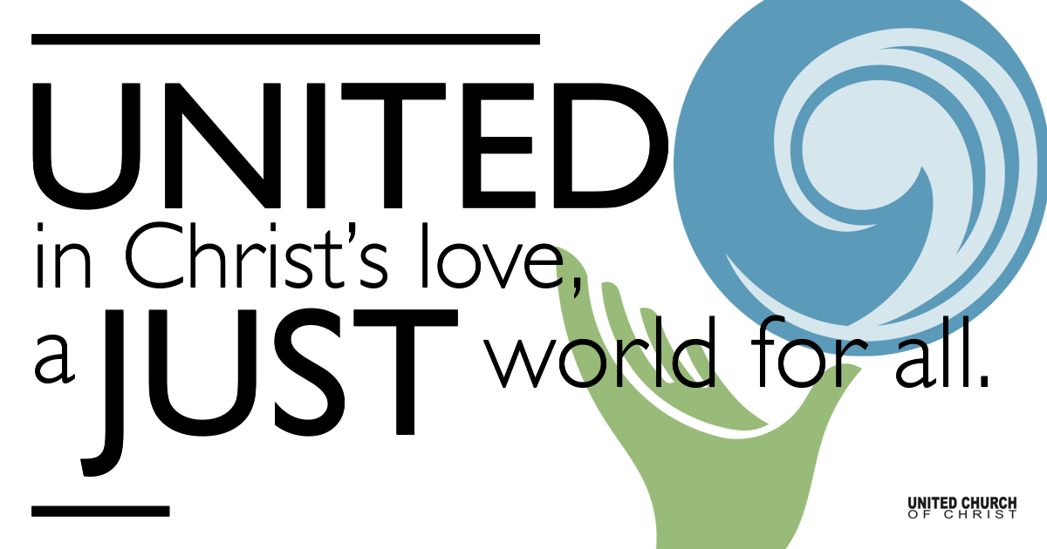
Silent Meditation

December 5, 2021

Second Sunday of Advent
First Light: Peaceful Dawn
“When the power of love overcomes the love of power the world will know peace.” - Jimi Hendrix

Prelude “This Is A Time of Mystery” Martie McMane

Welcome to Worship
One: Welcome to everyone, in every space!
Whoever you are and wherever you are on life’s journey,
ALL: We welcome you here.

Opening Comments

Lighting of the Advent Wreath
Hope is...
Trusting that there is light, even in the dark.
After hope, peace is born in the silence.
We wait quietly for the day to be reborn.
We light the candle of peace today to warm us as we wait for dawn.

Ringing of the Bell

Call to Worship (Luke 1:68-79, responsively)
One: Blessed be the God of Israel, who has looked favorably upon the people and redeemed them.
All: God has raised up a mighty savior for us in the house of David.
One: By the tender mercy of our God, the dawn from on high will break upon us.
All: It will give light to those who sit in darkness, to guide our feet into the way of peace.

Opening Song “Isaiah the Prophet” NCH #108

Children’s Chat & Blessing Rev. Chelsea Page
Wherever we are seated in the sanctuary or at home, Each one of us a twinkling light. Together we form a hopeful constellation in the dark sky of a predawn morning. You are the light of the world. Do not light your lamp to hide under a bowl. Go forth to Sunday School To shine your light before all and give glory to God!

Centering Song - O Come, Oh Come Emmanuel - Verse 1 (NCH #116)
O come, O come, Emmanuel,
and ransom captive Israel
That mourns in lonely exile here,
until the Child of God appear.
Rejoice! Rejoice! Emmanuel shall come to you, O Israel!

Prayer for Illumination

First Reading Baruch 5:1–5, NRSV

Centering Song - O Come, Oh Come Emmanuel - Verse 2 (NCH #116)
O come, O come, Emmanuel,
and order all things far and nigh;
To us the path of knowledge show,
and help us in that way to go.
Rejoice! Rejoice! Emmanuel shall come to you, O Israel!

Gospel Reading Luke 1:68-79

Centering Song - O Come, Oh Come Emmanuel - Verse 3 (NCH #116)
O come, Desire of Nations, bind
all peoples in one heart and mind;
Make envy, strife, and quarrels cease;
fill the whole world with heaven’s peace.
Rejoice! Rejoice! Emmanuel shall come to you, O Israel!

Reflection “Expect the Unexpected” Rev. Brent Gundlah

Call to Offering/Prayer of Dedication

Prayers of the Community
(If you would like to offer a prayer of gratitude or concern for someone or some situation please use first names for security. The congregation will respond to each prayerful offering with the following words:
“Together with God, we hear your prayers.”)

Pastoral Prayer

Song into Communion

Holy Communion

Communion Song “Harvest of Him” Martie McMane

Jesus Prayer

Words of Mission and Benediction

Extinguishing Candles and Taking the Light into the World

Closing Song “Canticle of the Turning” Rory Cooney

Parents, please collect your child(ren) from their teachers in McMullen Hall. Thank you!

Find out More!



holladayucc.org

Scan to Give & Connect with Us


Welcome parents! We are glad you and your child(ren) are here. Please begin worship seated together as a family. After Children’s Chat, children will walk to Sunday School with their teachers. We have classes for grades PK-2 and 3-6. Please pick up your child(ren) from McMullen Hall promptly after the service. Thank you!
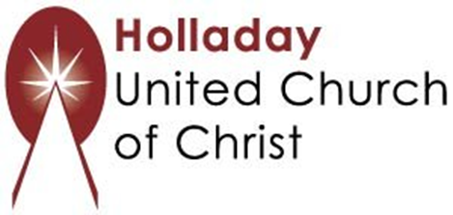
2631 East Murray-Holladay Rd
Holladay, UT 84117 801-277-2631
Rev. Brent Gundlah, Senior Pastor
Rev. Chelsea Page, Associate Pastor

We are a Creation Justice,
Open and Affirming Congregation
of the United Church of Christ.
Participants in Worship:
Reader: Bishop Family, Alle Maulden
Slides: Gary Duran, Sound: Chuck Dillard, Video: Jim Bale
Music: Carl Adams, Mark Dazley, Jani Gamble, Eric Richards
Children’s Chat: Rev. Chelsea Page

PRAYER REQUESTS
The following are offered for your prayers this morning and in the days ahead:
- Prayers of strength and comfort for all those who live in fear of violence.
- Prayers of support and gratitude for our community of caregivers.
- Prayers of healing for all who are facing health issues
- Prayers of comfort for all those in hospice care.

