~LIVESTREAMED TO FACEBOOK~
We are live streaming today’s worship service on Facebook, so we want you to know that your presence here today is your agreement and consent to being part of that recording.

~Please continue wearing your mask while in the Sanctuary~
~Offering plates will be located at the back of the Sanctuary~

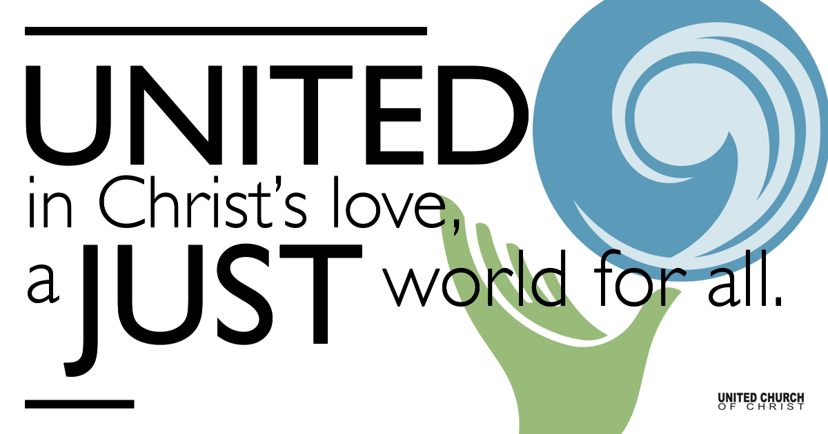
Silent Meditation

December 12, 2021

Third Sunday of Advent
First Light: Dawning Joy
“Joy is the infallible sign of the presence of God.”
— Pierre Teilhard de Chardin

Prelude “O Come, O Come, Emmanuel” Christi Miller

Welcome to Worship
One: Welcome to everyone, in every space!
Whoever you are and wherever you are on life’s journey,
ALL: We welcome you here.

Opening Comments

Lighting of the Advent Wreath
Hope is: Trusting that there is light, even in the dark.
Peace is: Feeling connected to all creation, waiting for the Son.
After peace, joy is a multitude of hearts singing Alleluia!
The Son is coming soon!
We light the candle of joy today to warm us as we wait for dawn.

Ringing of the Bell

Call to Worship (adapted from the Presbyterian Church in Canada)
One: God is in our midst.
All: Let us sing out loud and shout our praises!
One: God rejoices over us with gladness and renews us with love.
All: We will rejoice with all our hearts at what God has done!
One: With joy, let us draw water from the well of salvation.
All: God is our salvation; we will trust and have no fear.

Opening Song “Christmas Joy” Emerson

Children’s Chat & Blessing Rev. Chelsea Page
Wherever we are seated, in the sanctuary or at home,
Each one of us a twinkling light.
Together we form a hopeful constellation in the dark sky of a predawn morning.
You are the light of the world.
Do not light your lamp to hide under a bowl. Go forth to Sunday School
To shine your light before all and give glory to God!

“We invite you to sing our Centering Song quietly while remaining masked”

Centering Song - “It Came Upon the Midnight Clear”, Verse 1 (NCH #131)
It came upon the midnight clear, that glorious song of old,
from angels bending near the earth to touch their harps of gold;
“Peace on the earth, good will to all, great new of joy we bring.”
The world in solemn stillness lay to hear the angels sing.

Prayer for Illumination

First Reading Zephaniah 3:14-20, NSRV

Centering Song - “It Came Upon the Midnight Clear”, Verse 2 (NCH #131)
Still through the cloven skies they come, with peaceful wings unfurled,
and still their heavenly music floats o’er all the weary world;
Above its sad and lowly plains they bend on hovering wing,
and ever o’er its Babel sounds the blessed angels sing.

Gospel Reading Luke 3:7-18, NRSV

Centering Song - “It Came Upon the Midnight Clear”, Verse 3 (NCH #131)
And you, beneath life’s crushing load, whose forms are bending low,
Who toil along the climbing way, with painful steps and slow,
Look now, for glad and golden hours come swiftly on the wing,
O rest beside the weary road, and hear the angels sing!

Reflection “Be Kind” Rev. Brent Gundlah

Call to Offering/Prayer of Dedication

Prayers of the Community
(If you would like to offer a prayer of gratitude or concern for someone or some situation please use first names for security. The congregation will respond to each prayerful offering with the following words:
“Together with God, we hear your prayers.”)

Pastoral Prayer

Jesus Prayer

Words of Mission and Benediction

Extinguishing Candles and Taking the Light into the World

Closing Song “Comfort and Joy” J. Raney

Parents, please collect your child(ren) from their teachers in McMullen Hall. Thank you!

CHURCH OFFICE WILL BE CLOSED FROM DEC 20th THROUGH DEC 31st.

Find out More!



holladayucc.org

Scan to Give & Connect with Us


Welcome parents! We are glad you and your child(ren) are here. Please begin worship seated together as a family. After Children’s Chat, children will walk to Sunday School with their teachers. We have classes for grades PK-2 and 3-6. Please pick up your child(ren) from McMullen Hall promptly after the service. Thank you!
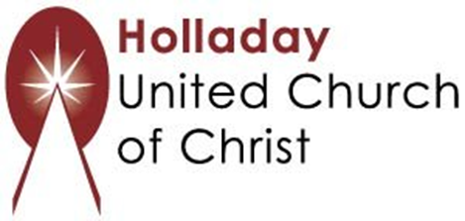
2631 East Murray-Holladay Rd
Holladay, UT 84117 801-277-2631
Rev. Brent Gundlah, Senior Pastor
Rev. Chelsea Page, Associate Pastor

We are a Creation Justice,
Open and Affirming Congregation
of the United Church of Christ.
Participants in Worship:
Readers: Nan Sturgeon and Noah Rains, Video: Jim Bale
Slides: Dale Berreth, Sound: Winston Gamble, Music: HUCC Choir
Candlelighters: Martin Family, Children’s Chat: Rev. Chelsea Page

PRAYER REQUESTS
The following are offered for your prayers this morning and in the days ahead:
- Prayers of strength and comfort for all those who live in fear of violence.
- Prayers of support and gratitude for our community of caregivers.
- Prayers of healing for all who are facing health issues
- Prayers of comfort for all those in hospice care.

