~LIVESTREAMED TO FACEBOOK~
We are live streaming today’s worship service on Facebook, so we want you to know that your presence here today is your agreement and consent to being part of that recording.

~Please continue wearing your mask while in the Sanctuary~
~Offering plates will be located at the back of the Sanctuary~

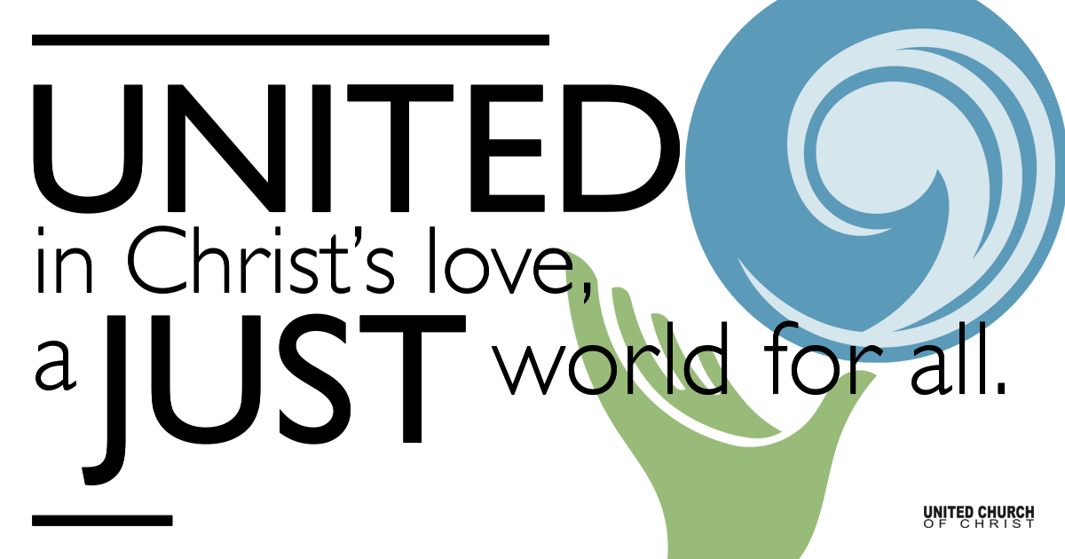
Silent Meditation

December 19, 2021

Fourth Sunday of Advent
First Light: The Dawn of Love
“While the tale of how we suffer, and how we are delighted, and how we may triumph is never new, it always must be heard. There isn’t any other tale to tell, it’s the only light we’ve got in all this darkness.” ~James Baldwin

Prelude Emmanuel Bob McGee

Welcome to Worship
One: Welcome to everyone, in every space!
Whoever you are and wherever you are on life’s journey,
ALL: We welcome you here.

Opening Comments

Lighting of the Advent Wreath

Ringing of the Bell

Call to Worship
One: Our souls magnify the Holy One
All: And our spirits rejoice in God who frees us.
One: God satisfies us with many good things
All: And challenges us to abandon empty pride.
One: God’s glorious Justice topples
All: Any pettiness or low expectation.
One: Today we worship God!

Opening Song “Awake, Awake, and Greet the New Morn” NCH#107

Children’s Chat & Blessing Martha Moler
Wherever we are seated, in the sanctuary or at home,
Each one of us a twinkling light.
Together we form a hopeful constellation in the dark sky of a predawn morning.
You are the light of the world.
Do not light your lamp to hide under a bowl. Go forth to Sunday School
To shine your light before all and give glory to God!

Centering Song “The First Nowell” (NCH#139) Verse 1
The First Nowell, the angel did say,
was to certain poor shepherds in fields as they lay;
In fields where they lay keeping their sheep
on a cold winter’s night that was so deep.
Nowell, nowell, nowell, nowell,
born in a manger, Emmanuel.

Prayer for Illumination

First Reading Micah 5:2-5a, NRSV

Centering Song “The First Nowell” (NCH#139)Verse 2
They looked above and saw a star
shining in the east, beyond them far,
And to the earth it gave great light,
and so it continued both day and night.
Nowell, nowell, nowell, nowell,
born in a manger, Emmanuel.

Gospel Reading Luke 1:39-55, NRSV

Centering Song “The First Nowell” (NCH#139) Verse 3
And by the light of that same star
three sages came from country far;
To seek for a king was in their tent,
and to follow the star wherever it went.
Nowell, nowell, nowell, nowell,
born in a manger, Emmanuel.

Reflection Rev. Chelsea Page

Call to Offering/Prayer of Dedication

Prayers of the Community
(If you would like to offer a prayer of gratitude or concern for someone or some situation please use first names for security. The congregation will respond to each prayerful offering with the following words:
“Together with God, we hear your prayers.”)

Pastoral Prayer

Jesus Prayer

Words of Mission and Benediction

Extinguishing Candles and Taking the Light into the World

Closing Song “Soon and Very Soon” Andre Crouch

Prayers adapted from UCC Worship Ways written by Stephanie Dorsey.

Parents, please collect your child(ren) from their teachers in McMullen Hall. Thank you!

CHURCH OFFICE WILL BE CLOSED FROM DEC 20th THROUGH DEC 31st.

Find out More!



holladayucc.org

Scan to Give & Connect with Us


Welcome parents! We are glad you and your child(ren) are here. Please begin worship seated together as a family. After Children’s Chat, children will walk to Sunday School with their teachers. We have classes for grades PK-2 and 3-6. Please pick up your child(ren) from McMullen Hall promptly after the service. Thank you!
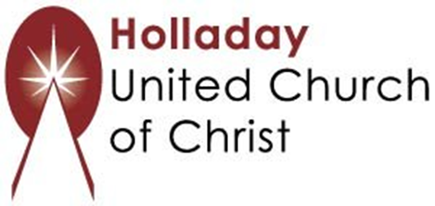
2631 East Murray-Holladay Rd
Holladay, UT 84117 801-277-2631
Rev. Brent Gundlah, Senior Pastor
Rev. Chelsea Page, Associate Pastor

We are a Creation Justice,
Open and Affirming Congregation
of the United Church of Christ.
Participants in Worship:
Reader: Debbie Wilkerson & Zain Yousef, Video: Jim Bale
Slides: Gary Duran, Sound: Connie Nomann, Music: Holy House Band
Candlelighters: Wirkus Family, Children’s Chat: Martha Moler

PRAYER REQUESTS
The following are offered for your prayers this morning and in the days ahead:
- Prayers of strength and comfort for all those who live in fear of violence.
- Prayers of support and gratitude for our community of caregivers.
- Prayers of healing for all who are facing health issues
- Prayers of comfort for all those in hospice care.

