~LIVESTREAMED TO FACEBOOK~
We are live streaming today’s worship service on Facebook, so we want you to know that your presence here today is your agreement and consent to being part of that recording.

~Please continue wearing your mask while in the Sanctuary~
~Offering plates will be located at the back of the Sanctuary~
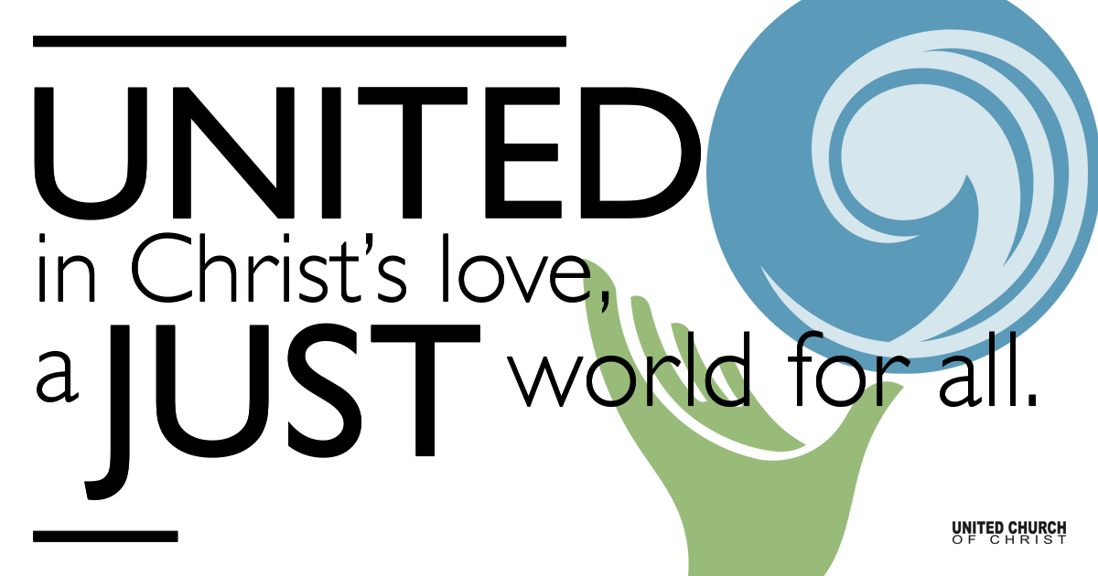

December 24, 2021

First Light: Christmas Eve
The Morning Star Rises
Prelude Carol of the Drum (the Little Drummer Boy) Katherine Davis
arranged by Stephen DeCesare
Cindy Gellner (clarinet), Jonathan Gellner (oboe), Daniel Gellner (drums)

Welcome

Call to Worship (Based on Isaiah 60:1-3)
One: Arise, shine; for your light has come, and the glory of God has risen upon you, though darkness covers the earth, and thick darkness covers the people.
All: The Holy One will arise upon us, and God's glory will appear over us.
One: Members of all nations shall come to this light. Even rulers shall worship at the brightness of this dawn.
All: Let us worship God!
One: We will now hold a moment of silence, as our candle lighters approach the Christ Candle on the chancel table, our Christmas Star.

Silent Meditation

Lighting of the Advent Wreath

Opening Song “O Little Town of Bethlehem” NCH 133, v 1-2
O little town of Bethlehem,
How still we see thee lie!
Above the deep and dreamless sleep
The silent stars go by;
Yet in thy dark streets shineth
The everlasting Light;
The hopes and fears of all the years
Are met in thee tonight.

For Christ is born of Mary,
And gathered all above,
While mortals sleep, the angels keep
Their watch of wondering love.
O morning stars together
Proclaim the holy birth!
And praises sing to God the King,
And peace to all on earth.

Prayer for a World at Night
God of starlight and angels, look down with kindness upon any feelings we may carry of grief and anger, fear and doubt.
Be with those who have suffered loss this year, for whom Christmas has transformed into a painful reminder of what once was.
Be with those spending their Christmas in a hospital, and with the doctors and nurses working to keep them alive.
Be with those spending their Christmases alone—may we see them, know them, and welcome them into our lives.
Be with the families who cannot afford holidays. Grant them joy and peace on this night. Amen.

Let us take a moment to bless our offering in advance:
All: God of hope, peace, joy, and love—
You have given us everything we have; from the magic of snowfall and tall strong evergreens, to the smell of home cooking and the sound of carols. You have given us everything, and yet when you were born into this world, all they gave you was a manger and some hay.
Thus, God of light we pray—take and use these gifts. Use them for your good so that others may be strengthened like the roots of an evergreen, and live in the warmth of your light. In deep gratitude we pray, Amen.

Song “What Child Is This?” William C Dix
What child is this who laid to rest, on Mary’s lap is sleeping?
Whom angels greet with anthems sweet
While shepherds watch are keeping.
This, this is Christ the king, whom shepherds guard and angels sing;
Joy, joy for Christ is born, the babe, the son of Mary.

First Reading (Isaiah 9:2, 6)

Second Reading (John 1:5, 14)

Song “Away in a Manger” NCH #124
Away in a manger, no crib for His bed, the little Lord Jesus lay down His sweet head. The stars in the sky looked down where He lay, the little Lord Jesus, asleep on the hay.
The cattle are lowing, the poor baby wakes, but little Lord Jesus, no crying he makes. I love you, Lord Jesus protect me, I pray, and stay by my side until night turns to day.

Reflection - Rev. Chelsea Page

Children’s Fishbowl Pageant “The Morning Star”
(Adapted from coloring books by The Christmas Fund)

Benediction

Closing Song ”Silent Night, Holy Night” NCH #134

Please consider donating to the work of Family Promise as you leave. Thank you for your generosity and Merry Christmas!

Find out More!



holladayucc.org

Scan to Give & Connect with Us
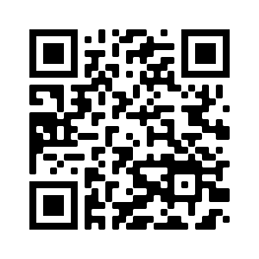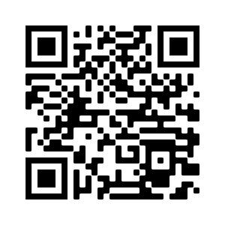

Welcome parents! We are glad you and your child(ren) are here. Please begin worship seated together as a family. After Children’s Chat, children will walk to Sunday School with their teachers. We have classes for grades PK-2 and 3-6. Please pick up your child(ren) from McMullen Hall promptly after the service. Thank you!
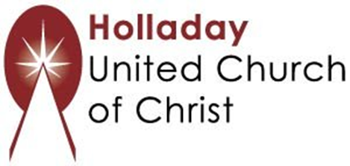
2631 East Murray-Holladay Rd
Holladay, UT 84117 801-277-2631
Rev. Brent Gundlah, Senior Pastor
Rev. Chelsea Page, Associate Pastor

We are a Creation Justice,
Open and Affirming Congregation
of the United Church of Christ.
Participants in Worship:
Readers: Pamela & Tiffini Adams, Ruby Hammel, Pageant Children
Sound: Carl Adams, Video: Roger Lamoni
Advent wreath lighters: Gellner Family
Music: Marilyn & Chuck Dillard

PRAYER REQUESTS
The following are offered for your prayers this morning and in the days ahead:
- Prayers of strength and comfort for all those who live in fear of violence.
- Prayers of support and gratitude for our community of caregivers.
- Prayers of healing for all who are facing health issues
- Prayers of comfort for all those in hospice care.

