~LIVESTREAMED TO FACEBOOK~
We are live streaming today’s worship service on Facebook, so we want you to know that your presence here today is your agreement and consent to being part of that recording.

~Please continue wearing your mask while in the Sanctuary~
~Offering plates will be located at the back of the Sanctuary~

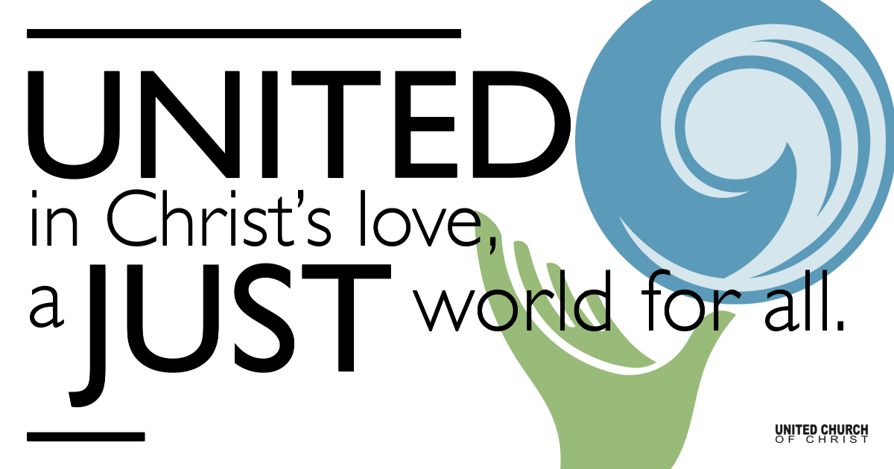
Silent Meditation

December 24, 2021

First Light: Christmas Eve
The Light Shines Forth
“The birth of Jesus made possible not just a new way of understanding life but a new way of living it.” - Frederick Buechner

Prelude “What Songs Were Sung” John Jacob Niles
Carolyn Klassen, soloist

Welcome to Worship

Prayer of Invocation

Lighting of the Advent Wreath
First Reader: Hope is:
Second Reader: Trusting that there is light, even in the dark.

Third Reader: Peace is:
Fourth Reader: Feeling connected to all creation, waiting for the Son.

First Reader: Joy is:
Second Reader: Contagious sounds of birds peeping Alleluias!

Third Reader: Love is:
Fourth Reader: Unquenchable, never-ending, rays of light appearing.

First Reader: After love, Christmas is:
Second Reader: A love song to the world; the light that shines in darkness.
Third Reader: The light of Christ has dawned
Fourth Reader: Nothing can quench this fire of Love
First Reader: Nothing can overshadow this Light.

Congregational Carol ”O Come, All Ye Faithful” NCH #135, v 1,3
O come, all ye faithful, joyful and triumphant,
O come ye, O come ye to Bethlehem;
Come and behold him, born the King of angels;

Refrain:
O come, let us adore him,
O come, let us adore him,
O come, let us adore him,
Christ, the Lord!

Sing, choirs of angels, sing in exultation,
Sing, all ye messengers of heavenly love
Glory to God, all glory in the highest;
(Refrain)

First Reading Isaiah 9:2, 6-7
The people who walked in darkness have seen a great light; those who live. For a child has been born for us, a son given to us; authority rests upon his shoulders; and he is named Wonderful Counselor, Mighty God, Everlasting Father, Prince of Peace.
His authority shall grow continually, and there shall be endless peace for the throne of David and his kingdom. He will establish and uphold it with justice and with righteousness from this time onward and forevermore. The zeal of the Lord of hosts will do this.

Congregational Carol “Angels We Have Heard on High” NCH #125, v 1-2
Angels we have heard on high, sweetly singing o’er the plains,
And the mountains in reply, echo back their joyous strains.

Chorus:
Gloria in excelsis Deo, Gloria in excelsis Deo.

Shepherds, why this jubilee? Why your joyous strains prolong?
What the gladsome tidings be, which inspire your heav’nly song? (Chorus)

Second Reading Luke 1:26-33
In the sixth month the angel Gabriel was sent by God to a town in Galilee called Nazareth, to a virgin engaged to a man whose name was Joseph, of the house of David. The virgin’s name was Mary. And he came to her and said, “Greetings, favored one! The Lord is with you.” But she was much perplexed by his words and pondered what sort of greeting this might be. The angel said to her, “Do not be afraid, Mary, for you have found favor with God. And now, you will conceive in your womb and bear a son, and you will name him Jesus. He will be great, and will be called the Son of the Most High, and the Lord God will give to him the throne of his ancestor David. He will reign over the house of Jacob forever, and of his kingdom there will be no end.”

Special Music “Be Born in Me” Francesca Battistelli
Allison Ottley, soloist

Third Reading Luke 2:1-7
In those days a decree went out from Emperor Augustus that all the world should be registered. This was the first registration and was taken while Quirinius was governor of Syria. All went to their own towns to be registered. Joseph also went from the town of Nazareth in Galilee to Judea, to the city of David called Bethlehem, because he was descended from the house and family of David. He went to be registered with Mary, to whom he was engaged and who was expecting a child. While they were there, the time came for her to deliver her child. And she gave birth to her firstborn son and wrapped him in bands of cloth, and laid him in a manger, because there was no place for them in the inn.

Congregational Carol “Hark the Herald Angels Sing” NCH 144, v 1-2
Hark! the herald angels sing,
“Glory to the newborn King;
Peace on earth, and mercy mild,
God and sinners reconciled!”
Joyful, all ye nations, rise,
Join the triumph of the skies;
With the angelic host proclaim,
“Christ is born in Bethlehem!”
Hark! the herald angels sing,
“Glory to the new-born King!”

Christ, by highest adored;
Christ, the everlasting Lord!
Late in time behold him come,
Off-spring of the Virgin’s womb.
Veiled in flesh the God-head see;
Hail the incarnate Deity,
Pleased as man with men to dwell,
Jesus, our Emmanuel.
Hark! the herald angels sing,
“Glory to the new-born King!”
Hark! the herald angels sing,
“Glory to the new-born King!”

Fourth Reading Luke 2:8-14 9
In that region there were shepherds living in the fields, keeping watch over their flock by night. Then an angel of the Lord stood before them, and the glory of the Lord shone around them, and they were terrified. But the angel said to them, “Do not be afraid; for see—I am bringing you good news of great joy for all the people: to you is born this day in the city of David a Savior, who is the Messiah, the Lord. This will be a sign for you: you will find a child wrapped in bands of cloth and lying in a manger.” And suddenly there was with the angel a multitude of the heavenly host, praising God and saying, “Glory to God in the highest heaven, and on earth peace among those whom he favors!”

Congregational Carol “O Little Town of Bethlehem” NCH 133, v 1-2
O little town of Bethlehem,
How still we see thee lie!
Above the deep and dreamless sleep
The silent stars go by;
Yet in thy dark streets shineth
The everlasting Light;
The hopes and fears of all the years
Are met in thee tonight.

For Christ is born of Mary,
And gathered all above,
While mortals sleep, the angels keep
Their watch of wondering love.
O morning stars together
Proclaim the holy birth!
And praises sing to God the King,
And peace to all on earth.

Homily

Special Music “God Is With Us” Casting Crowns
Mona Stevens, soloist

Pastoral Prayer [incl. offering prayer]

Fifth Reading (Pastor Brent) John 1:1-5
In the beginning was the Word, and the Word was with God, and the Word was God. He was in the beginning with God. All things came into being through him, and without him not one thing came into being. What has come into being in him was life, and the life was the light of all people. The light shines in the darkness, and the darkness did not overcome it.

Sharing the Light of Christ

Congregational Carol ”Silent Night, Holy Night” NCH #134
Silent night, Holy night,
All is calm, all is bright
Round yon virgin mother and child.
Holy infant so tender and mild
Sleep in heavenly peace,
Sleep in heavenly peace.

Silent night, holy night,
Shepherds quake at the sight,
Glories stream from heaven afar
Heavenly hosts sing Alleluia;
Christ the Savior is born,
Christ the Savior is born.

Silent night, holy night,
Son of God, love’s pure light,
Radiant beams from Thy holy face
With the dawn of redeeming grace;
Jesus, Lord at thy birth,
Jesus, Lord at thy birth.

Benediction

Response “Joy to the World” NCH #132
Joy to the world! The Lord is come: Let earth receive her king
Let every heart prepare him room,
And heaven and nature sing, and heaven and nature sing,
And heaven and heaven and nature sing.

Joy to the earth! The Savior reigns! Let all their songs employ;
While fields and floods, rocks, hills, and plains
Repeat the sounding joy, repeat the sounding joy,
Repeat, repeat the sounding joy.

He rules the world with truth and grace, and makes the nations prove
The glories of God’s righteousness
And wonders of God’s love, And wonders of God’s love,
And wonders of God’s love,
And wonders and wonders of God’s love.

Find out More!



holladayucc.org

Scan to Give & Connect with Us


Welcome parents! We are glad you and your child(ren) are here. Please begin worship seated together as a family. After Children’s Chat, children will walk to Sunday School with their teachers. We have classes for grades PK-2 and 3-6. Please pick up your child(ren) from McMullen Hall promptly after the service. Thank you!
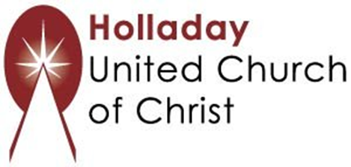
2631 East Murray-Holladay Rd
Holladay, UT 84117 801-277-2631
Rev. Brent Gundlah, Senior Pastor
Rev. Chelsea Page, Associate Pastor

We are a Creation Justice,
Open and Affirming Congregation
of the United Church of Christ.
Participants in Worship:
Advent wreath lighters: Hanrahan Family
Readers: Jim Bale, Debbie Wilkerson, Ruby Ostermann, Shesh Tipton
Sound: Winston Gamble, Greeters: Kathy Gamble, Marcus Pegasus
Music: Tom Klassen, Carolyn Klassen, Allison Ottley, Mona Stevens
Video: Jim Bale, Lights: ______________

PRAYER REQUESTS
The following are offered for your prayers this morning and in the days ahead:
- Prayers of strength and comfort for all those who live in fear of violence.
- Prayers of support and gratitude for our community of caregivers.
- Prayers of healing for all who are facing health issues
- Prayers of comfort for all those in hospice care.

