~LIVESTREAMED TO FACEBOOK~
We are live streaming today’s worship service on Facebook, so we want you to know that your presence here today is your agreement and consent to being part of that recording.

~Please continue wearing your mask while in the Sanctuary~
~Offering plates will be located at the back of the Sanctuary~

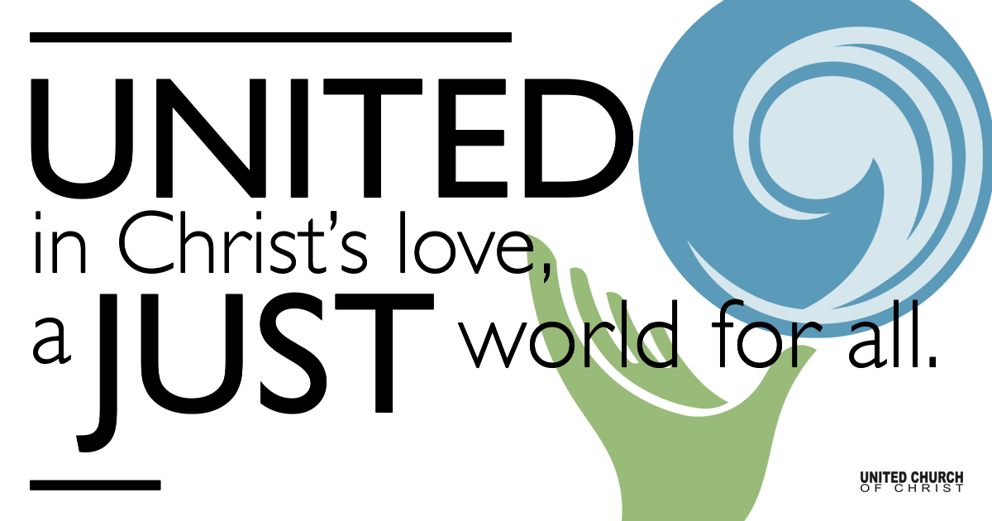
Silent Meditation

December 26, 2021

First Sunday after Christmas Day
Young Prophets
You are only young once, but you can stay immature indefinitely.”
― Ogden Nash

Prelude “Away in a Manger” NCH #124

Welcome to Worship
One: Welcome to everyone, in every space!
Whoever you are and wherever you are on life’s journey,
ALL: We welcome you here.

Opening Comments

Entrance of Light & Ringing of the Bell

Call to Worship (from Psalm 148, responsively)
One: Praise God! Praise God from the heavens.
All: Praise God in the heights. Praise God, all you angels.
One: Praise God from the earth.
All: Young and old alike, all God’s children together. Praise God!

Opening Song “Hark the Herald Angels Sing” NCH #144

Children’s Chat & Blessing Jim Bale
Though we gather separately, we are one community
In the sanctuary, playground or at home.
As the children depart for Sunday School,
Our hearts are shining with Christmas Love.
Love is the reason we are here.
God is here with us, And God is out there, too!
Go with God. Amen.

Prayer for Illumination

First Reading 1 Samuel 2:18-20,26, NRSV
Samuel was ministering before the Lord, a boy wearing a linen ephod. His mother used to make for him a little robe and take it to him each year, when she went up with her husband to offer the yearly sacrifice. Then Eli would bless Elkanah and his wife, and say, “May the Lord repay you with children by this woman for the gift that she made to the Lord ”; and then they would return to their home. Now the boy Samuel continued to grow both in stature and in favor with the Lord and with the people.

Gospel Reading Luke 2:41-52, NRSV
Now every year his parents went to Jerusalem for the festival of the Passover. And when he was twelve years old, they went up as usual for the festival. When the festival was ended and they started to return, the boy Jesus stayed behind in Jerusalem, but his parents did not know it. Assuming that he was in the group of travelers, they went a day’s journey. Then they started to look for him among their relatives and friends. When they did not find him, they returned to Jerusalem to search for him. After three days they found him in the temple, sitting among the teachers, listening to them and asking them questions. And all who heard him were amazed at his understanding and his answers. When his parents saw him they were astonished; and his mother said to him, “Child, why have you treated us like this? Look, your father and I have been searching for you in great anxiety.” He said to them, “Why were you searching for me? Did you not know that I must be in my Father’s house?” But they did not understand what he said to them. Then he went down with them and came to Nazareth, and was obedient to them. His mother treasured all these things in her heart. And Jesus increased in wisdom and in years, and in divine and human favor.

Reflection “Forever Young” Rev. Brent Gundlah

Call to Offering/Prayer of Dedication

Prayers of the Community
(If you would like to offer a prayer of gratitude or concern for someone or some situation please use first names for security. The congregation will respond to each prayerful offering with the following words:
“Together with God, we hear your prayers.”)

Pastoral Prayer

Jesus Prayer
Our Creator who is in heaven,
Hallowed be Your name,
Your reign come, Your will be done,
On earth as it is in heaven,
Give us this day our daily bread,
And forgive us our debts as we forgive our debtors,
And lead us not into temptation, but deliver us from evil,
For Yours is the reign, the power, and glory for ever. Amen.

Words of Mission and Benediction

Closing Song “Go Tell It on the Mountain” NCH #154

Parents, please collect your child(ren) from their teachers in McMullen Hall. Thank you!

CHURCH OFFICE WILL BE CLOSED FROM DEC 20th THROUGH DEC 31st.

Find out More!



holladayucc.org

Scan to Give & Connect with Us


Welcome parents! We are glad you and your child(ren) are here. Please begin worship seated together as a family. After Children’s Chat, children will walk to Sunday School with their teachers. We have classes for grades PK-2 and 3-6. Please pick up your child(ren) from McMullen Hall promptly after the service. Thank you!
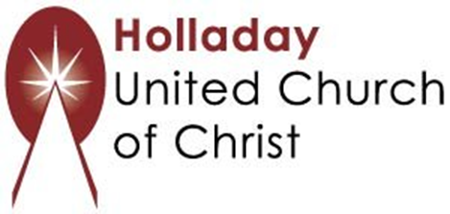
2631 East Murray-Holladay Rd
Holladay, UT 84117 801-277-2631
Rev. Brent Gundlah, Senior Pastor
Rev. Chelsea Page, Associate Pastor

We are a Creation Justice,
Open and Affirming Congregation
of the United Church of Christ.
Participants in Worship:
Reader: Debbie Wilkerson & Zain Yousef, Video: Jim Bale
Slides: Gary Duran, Sound: Connie Nomann, Music: Holy House Band
Candlelighters: Wirkus Family, Children’s Chat: Martha Moler

PRAYER REQUESTS
The following are offered for your prayers this morning and in the days ahead:
- Prayers of strength and comfort for all those who live in fear of violence.
- Prayers of support and gratitude for our community of caregivers.
- Prayers of healing for all who are facing health issues
- Prayers of comfort for all those in hospice care.

