~LIVESTREAMED TO FACEBOOK~
We are live streaming today’s worship service on Facebook, so we want you to know that your presence here today is your agreement and consent to being part of that recording.

~Please wear your mask while in the Sanctuary; you may respond and sing through your mask~
~Offering plates are located at the back of the Sanctuary~

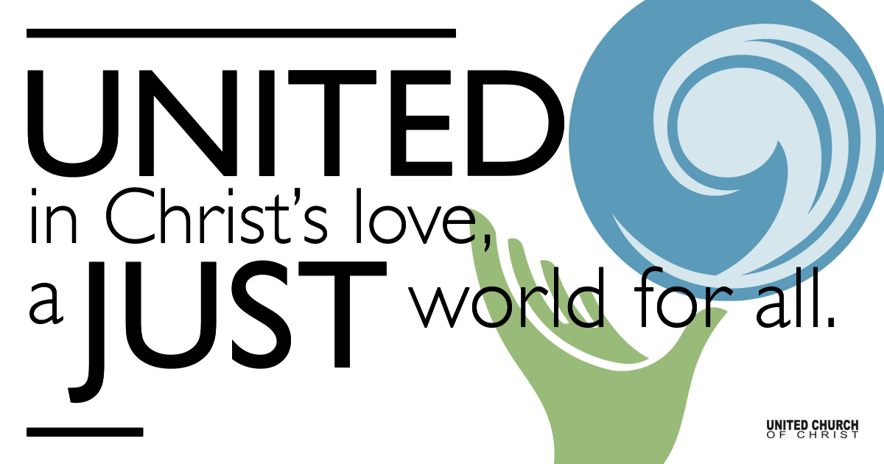
Silent Meditation

January 2, 2022

Second Sunday after Christmas Day
Shine On
“How far that little candle throws his beam! So shines a good deed in a weary world.” - Shakespeare, Merchant of Venice

Prelude Sleepy Jesus Rag Traditional

Welcome to Worship
One: Welcome to everyone, in every space!
Whoever you are and wherever you are on life’s journey,
All: We welcome you here!

Opening Comments

Entrance of Light & Ringing of the Bell

Call to Worship (based on Ephesians 1:3-14)
One: God’s goodness is built into the foundation of Creation!
God chose us in Christ from the beginning.
God calls us blameless, holy, and loved.
All: For the grace of God has been born in us!
One: God has made an eternal promise to gather all things.
God will reconcile all things on earth and heaven in the fullness of time.
In Jesus Christ we have heard the message of Love.
All: Christ has been born again into the world! Let us worship God.

Opening Song Morning Has Broken by Eleanor Farjeon

Children’s Chat & Blessing Rev. Brent Gundlah

Though we gather separately, we are one community
In the sanctuary, playground or at home.
As the children depart for Sunday School,
Our hearts are shining with Christmas Love.
Love is the reason we are here.
God is here with us, And God is out there, too!
Go with God. Amen.

Prayer for Illumination

First Reading Sirach 24:1-6, 9

Gospel Reading John 1:1-5, 9-14, 18

Reflection “Bosom Buddies” Rev. Chelsea Page

Call to Offering/Prayer of Dedication

Prayers of the Community
(If you would like to offer a prayer of gratitude or concern for someone or some situation please use first names for security. The congregation will respond to each prayerful offering with the following words:
“Together with God, we hear your prayers.”)

Pastoral Prayer

Invitation to the Table

Communion Song Ook Pik Waltz by Frankie Rodgers

Holy Communion

Jesus Prayer

Our Creator who is in heaven,
Hallowed be Your name,
Your reign come, Your will be done,
On earth as it is in heaven,
Give us this day our daily bread,
And forgive us our debts as we forgive our debtors,
And lead us not into temptation, but deliver us from evil,
For Yours is the reign, the power, and glory for ever. Amen.

Words of Mission and Benediction

Closing Song This Little Light if Mine

Parents, please collect your child(ren) from their teachers in McMullen Hall. Thank you!

Participants in Worship:
Reader: Nan Sturgeon; Slides: Gary Duran
Video: Chuck Dillard; Music: Mary Otterstrom and Jimmy Ingold
Children’s Chat: Rev. Brent Gundlah

Welcome parents! We are glad you and your child(ren) are here. Please begin worship seated together as a family. After Children’s Chat, children will walk to Sunday School with their teachers. We have classes for grades PK-2 and 3-6. Please pick up your child(ren) from McMullen Hall promptly after the service. Thank you!

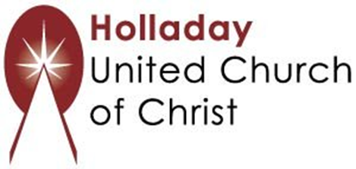




Find us on social media!

Scan to Give & Connect with Us
2631 East Murray-Holladay Rd
Holladay, UT 84117 801-277-2631
Rev. Brent Gundlah, Senior Pastor
Rev. Chelsea Page, Associate Pastor
www.holladayucc.org

We are a Creation Justice,
Open and Affirming Congregation
of the United Church of Christ.



PRAYER REQUESTS
The following are offered for your prayers this morning and in the days ahead:
• Prayers of strength and comfort for all those who live in fear of violence.
• Prayers of support and gratitude for our community of caregivers.
• Prayers of healing for all who are facing health issues
• Prayers of comfort for all those in hospice care.

