~LIVESTREAMED TO FACEBOOK~
We are live streaming today’s worship service on Facebook, so we want you to know that your presence here today is your agreement and consent to being part of that recording.

~Please continue wearing your mask while in the Sanctuary~
~Offering plates will be located at the back of the Sanctuary~

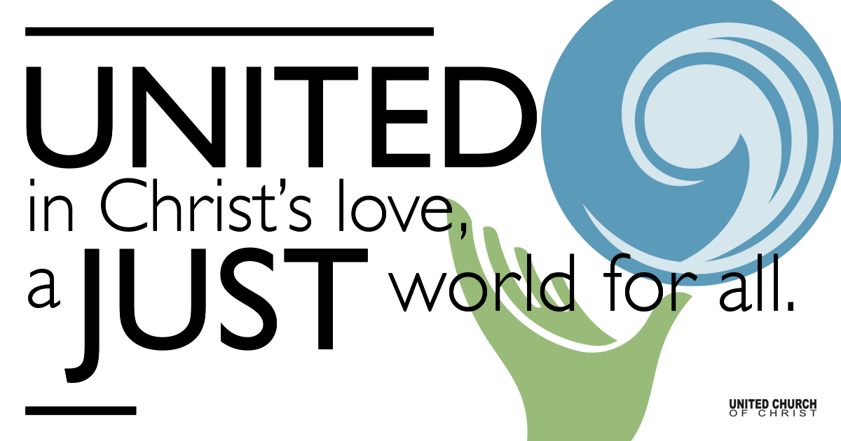
Silent Meditation

January 9, 2022

First Sunday after the Epiphany
The Baptism of Jesus

”Sometimes I think what the church needs most is to recover some of its weird... In the ritual of baptism, our ancestors acted out the bizarre truth of the Christian identity: We are people who stand totally exposed before evil and death and declare them powerless against love. There’s nothing normal about that.” - Rachel Held Evans

Prelude “The Healing Has Begun” Matthew West

Welcome to Worship
One: Whoever you are and wherever you are on life’s journey,
ALL: We welcome you here.

Opening Comments

Entrance of Light & Ringing of the Bell

Call to Worship (responsively, based on Psalm 29 and adapted from The Church of Scotland)
Leader: God calls us by name.
All: Come, let us worship God.
Leader: God's presence is with us.
All: Come, let us worship our Creator.
Leader: God takes away our fears.
All: Come, let us worship our Redeemer.
Leader: To God belongs all glory.
All: We have come from the East, West, South, and North. We come with hearts of praise. We come to listen for the voice of God.

Opening Song “Gathered Here” Phil Porter
Gathered here in the mystery of this hour
Gathered here in one strong body
Gathered here in the struggle and the power
Spirit draw near

Children’s Chat Martha Moler

Prayer for Illumination

Scripture First Reading (Acts 8:14-17, NRSV)
Gospel Reading (Luke 3:15-17, 21-22, NRSV)

Reflection “God’s Children” Rev. Brent Gundlah

Call to Offering/Prayer of Dedication

Prayers of the Community
(If you would like to offer a prayer of gratitude or concern for someone or some situation please use first names for security. The congregation will respond to each prayerful offering with the following words:
“Together with God, we hear your prayers.”)

Pastoral Prayer

Jesus Prayer

The Sacrament of Baptism

Welcome
Leader: Members and friends in Christ, we gather now to celebrate the gift of grace in the sacrament of baptism.
All: There is one body and one Spirit. There is one hope in God’s call to us.

Leader: There is one Lord, one faith, one baptism, one God and Creator of us all.

Address

Questions of the Candidate

*Promise of Congregation
Leader: Jesus Christ calls us to make disciples of all nations and to offer them the gift of grace in baptism. Do you, who witness and celebrate this sacrament, promise your love, support, and care to Tina as she lives and grows in Christ?
All: We promise our love, support, and care.

*Affirmation of Faith
Leader: Let us unite with the church in all times and places in confessing our faith. Do you believe in God?
All: I believe in God.
Leader: Do you believe in Jesus Christ?
All: I believe in Jesus Christ.
Leader: Do you believe in the Holy Spirit?
All: I believe in the Holy Spirit.

Prayer of Baptism

Act of Baptism

Prayer

Words of Mission and Benediction

Closing Song “The River” Jordan Feliz

Find out More!



holladayucc.org

Scan to Give & Connect with Us


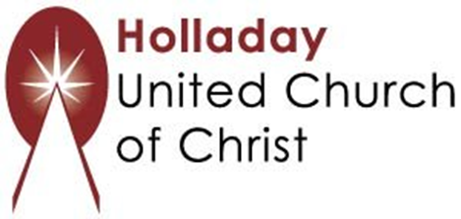
2631 East Murray-Holladay Rd
Holladay, UT 84117 801-277-2631
Rev. Brent Gundlah, Senior Pastor
Rev. Chelsea Page, Associate Pastor

We are a Creation Justice,
Open and Affirming Congregation
of the United Church of Christ.
Participants in Worship:
Reader: Heather Bertotti Sarin, Slides: Dale Berreth, Video: ______________
Music: Carl Adams, Mark Dazley, Amy Boettger, Tom Klassen,
Shelley McCall, Jonathon Green & Jani Gamble
Children’s Chat: Rev. Martha Moler

PRAYER REQUESTS
The following are offered for your prayers this morning and in the days ahead:
- Prayers of strength and comfort for all those who live in fear of violence.
- Prayers of support and gratitude for our community of caregivers.
- Prayers of healing for all who are facing health issues
- Prayers of comfort for all those in hospice care.

