~LIVESTREAMED TO FACEBOOK~
We are live streaming today’s worship service on Facebook, so we want you to know that your presence here today is your agreement and consent to being part of that recording.

~Please continue wearing your mask while in the Sanctuary~
~Offering plates will be located at the back of the Sanctuary~

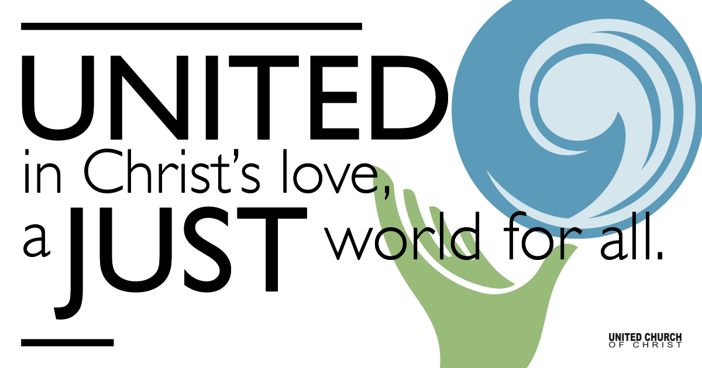
Silent Meditation

January 16, 2022

Second Sunday after the Epiphany
Gifts of the Spirit

"We must use time creatively, in the knowledge that the time is always ripe to do right." - Rev. Dr. Martin Luther King Jr.

Prelude “Listen To the Silence” Barbara Swetina

Welcome to Worship
One: Whoever you are and wherever you are on life’s journey,
ALL: We welcome you here.

Opening Comments

Entrance of Light & Ringing of the Bell

Call to Worship (responsively, from UCC Worship Ways)
Leader: Our Mother-Father God has made us to be One Body with many members.
All: United and uniting. This is our calling.
Leader: God calls us to share our diverse gifts activated by the one and same Spirit.
All: United and uniting. This is our redemption.

Leader: God longs for us to be united in love and to manifest the Spirit in our different ways.
All: United and uniting. This is our worship.
Leader: Let us gather in this hour to offer praise and worship to our Holy God, who challenges us and calls us to create the Beloved Community.

Opening Song “Precious Lord” NCH #472

Children’s Chat Nan Sturgeon

Prayer for Illumination

Scripture First Reading (1 Corinthians 12:1-11, NRSV)
Now concerning spiritual gifts, brothers and sisters, I do not want you to be uninformed. You know that when you were pagans, you were enticed and led astray to idols that could not speak. Therefore I want you to understand that no one speaking by the Spirit of God ever says “Let Jesus be cursed!” and no one can say “Jesus is Lord” except by the Holy Spirit.
Now there are varieties of gifts, but the same Spirit; and there are varieties of services, but the same Lord; and there are varieties of activities, but it is the same God who activates all of them in everyone. To each is given the manifestation of the Spirit for the common good. To one is given through the Spirit the utterance of wisdom, and to another the utterance of knowledge according to the same Spirit, to another faith by the same Spirit, to another gifts of healing by the one Spirit, to another the working of miracles, to another prophecy, to another the discernment of spirits, to another various kinds of tongues, to another the interpretation of tongues. All these are activated by one and the same Spirit, who allots to each one individually just as the Spirit chooses.

Gospel Reading (John 2:1-11, NRSV)
On the third day there was a wedding in Cana of Galilee, and the mother of Jesus was there. Jesus and his disciples had also been invited to the wedding. When the wine gave out, the mother of Jesus said to him, “They have no wine.” And Jesus said to her, “Woman, what concern is that to you and to me? My hour has not yet come.” His mother said to the servants, “Do whatever he tells you.” Now standing there were six stone water jars for the Jewish rites of purification, each holding twenty or thirty gallons. Jesus said to them, “Fill the jars with water.” And they filled them up to the brim. He said to them, “Now draw some out, and take it to the chief steward.” So they took it. When the steward tasted the water that had become wine, and did not know where it came from (though the servants who had drawn the water knew), the steward called the bridegroom and said to him, “Everyone serves the good wine first, and then the inferior wine after the guests have become drunk. But you have kept the good wine until now.” Jesus did this, the first of his signs, in Cana of Galilee, and revealed his glory; and his disciples believed in him.

Reflection “Gifts” Rev. Brent Gundlah

Call to Offering/Prayer of Dedication

Prayers of the Community
(If you would like to offer a prayer of gratitude or concern for someone or some situation please use first names for security. The congregation will respond to each prayerful offering with the following words:
“Together with God, we hear your prayers.”)

Pastoral Prayer

Jesus Prayer
Our Creator who is in heaven,
Hallowed be Your name,
Your reign come, Your will be done,
On earth as it is in heaven,
Give us this day our daily bread,
And forgive us our debts as we forgive our debtors,
And lead us not into temptation, but deliver us from evil,
For Yours is the reign, the power, and glory for ever. Amen.

Words of Mission and Benediction

Closing Song “Magnificat” Taize

Find out More!



holladayucc.org

Scan to Give & Connect with Us


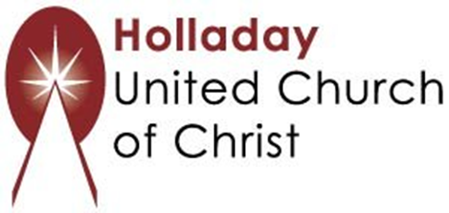
2631 East Murray-Holladay Rd
Holladay, UT 84117 801-277-2631
Rev. Brent Gundlah, Senior Pastor
Rev. Chelsea Page, Associate Pastor

We are a Creation Justice,
Open and Affirming Congregation
of the United Church of Christ.
Participants in Worship:
Reader: Debbie Wilkerson, Slides: Martha Bale, Video: Jim Bale
Music: Jim Bale, Pam Erickson, Eric Richards, Jani Gamble
Children’s Chat: Nan Sturgeon, Sound: Chuck Dillard

PRAYER REQUESTS
The following are offered for your prayers this morning and in the days ahead:
- Prayers of strength and comfort for all those who live in fear of violence.
- Prayers of support and gratitude for our community of caregivers.
- Prayers of healing for all who are facing health issues
- Prayers of comfort for all those in hospice care.

