~LIVESTREAMED TO FACEBOOK~
We are live streaming today’s worship service on Facebook, so we want you to know that your presence here today is your agreement and consent to being part of that recording.

~Please continue wearing your mask while in the Sanctuary~
~Offering plates will be located at the back of the Sanctuary~

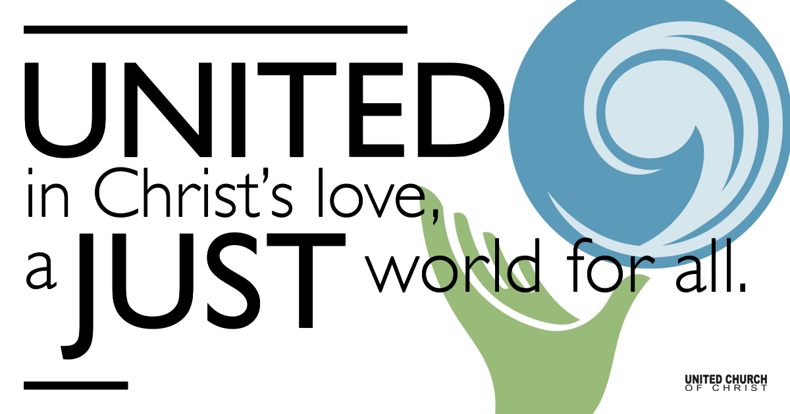
Silent Meditation

January 23, 2022

Third Sunday after the Epiphany
Church Anew
“The gifts we bring God are not what God needs, but what we need to give away.” - Maren Tirabassi

Prelude “Banner of Hope” Mary Susan Gast, SPP#75

Welcome to Worship
One: Welcome everyone, in every space and in every place.
Whoever you are and wherever you are on life’s journey,
ALL: We welcome you here.

Opening Comments

Entrance of Light & Ringing of the Bell

Call to Worship Adapted from Marcia McFee/Worship Design Studio
One: The Spirit of God is upon us! We have been anointed with an important job to do.
All: When we gather as Christ’s body, we perceive that a better world is coming.
One: Good news for the poor; good news to set us free.

All: Together we see what we could not see before: God is proclaiming a year of justice!
One: Come, Spirit, come and be a new reality. You are the reason this gathering is a holy place.
All: Come, Christ, who makes us one in prayer and praise. Renew in us the desire for justice and peace, liberation and life, now and every day. Amen.

Opening Song “Drawn to the Light” John Ylvisaker

Children’s Chat Rev. Brent Gundlah

Prayer for Illumination
O Divine Word, your instruction is perfect, reviving one’s very being. Your laws are faithful, helping naive people become wise. Your ideas are right, gladdening the heart. Your commands are pure, giving light to the eyes. Illumine our hearts with your words of scripture today. Amen.

Scripture 1 Corinthians 12:12-31a

Luke 4:14-21

Reflection “Anointed As One” Rev. Chelsea Page

Call to Offering/Prayer of Dedication
We share from what we have and from who we are
as a sign of our desire to bring good news to the poor.
May these gifts bring light to those in need,
and put the joy of the Lord in their hearts.
O God of all gifts, we join with Jesus in proclaiming the year of your favor.
Bless our gifts and bless us as we seek to bring joy and comfort to those who are unknown to us, and to those who are near and beloved. Amen.
(The Year of the Lord’s Favor: Service Prayers for Epiphany 3 C was written by Debbie Gline Allen in the UCC.)

Prayers of the Community
(If you would like to offer a prayer of gratitude or concern for someone or some situation please use first names for security. The congregation will respond to each prayerful offering with the following words:
“Together with God, we hear your prayers.”)

Pastoral Prayer

Jesus Prayer
Our Creator who is in heaven,
Hallowed be Your name,
Your reign come, Your will be done,
On earth as it is in heaven,
Give us this day our daily bread,
And forgive us our debts as we forgive our debtors,
And lead us not into temptation, but deliver us from evil,
For Yours is the reign, the power, and glory for ever. Amen.

Words of Mission and Benediction
Christ has no body but yours.
No hands, no feet on earth but yours.
Yours are the eyes through which he looks compassion on this world.
Yours are the feet with which he walks to do good.
Yours are the hands through which he blesses all the world.
Yours are the hands, yours are the feet,
yours are the eyes, you are his body.
Christ has no body now on earth but yours.
Go in peace to love and serve. Amen.
(attributed to St. Teresa of Avila)

Closing Song “This is the Day of new Beginnings”
Words by Brian Wren, Tune: Morning Has Broken

Find out More!



holladayucc.org

Scan to Give & Connect with Us


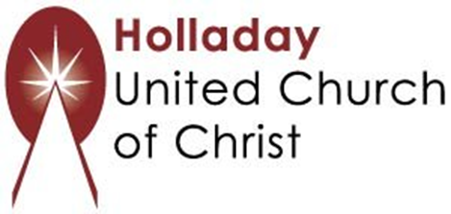
2631 East Murray-Holladay Rd
Holladay, UT 84117 801-277-2631
Rev. Brent Gundlah, Senior Pastor
Rev. Chelsea Page, Associate Pastor

We are a Creation Justice,
Open and Affirming Congregation
of the United Church of Christ.
Participants in Worship:
Reader: Esther Manning, Slides: Kyla Asmar, Sound: Connie Nomann
Music: Chuck and Marilyn Dillard, Eric Richards, Shesh Tipton, Jim Wetzel, Mark Dazley, Christopher Thomas, Children’s Chat: Rev. Brent Gundlah

PRAYER REQUESTS
The following are offered for your prayers this morning and in the days ahead:
- Prayers of strength and comfort for all those who live in fear of violence.
- Prayers of support and gratitude for our community of caregivers.
- Prayers of healing for all who are facing health issues
- Prayers of comfort for all those in hospice care.

