~LIVESTREAMED TO FACEBOOK~
We are live streaming today’s worship service on Facebook, so we want you to know that your presence here today is your agreement and consent to being part of that recording.

~Please continue wearing your mask while in the Sanctuary~
~Offering plates will be located at the back of the Sanctuary~

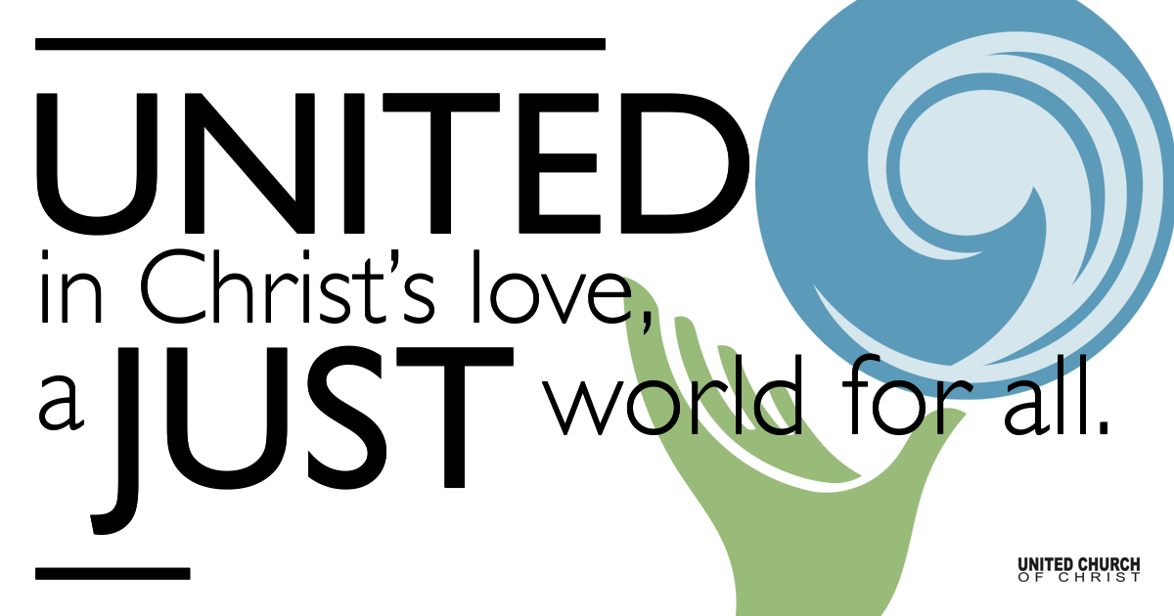
Silent Meditation

January 30, 2022

Fourth Sunday after the Epiphany
Love Never Ends
“With our love, we could save the world.” - George Harrison

Prelude “Building a New Way” Martha Sandefer
Start with love, that is the seed

Welcome to Worship
One: Whoever you are and wherever you are on life’s journey,
ALL: We welcome you here.

Opening Comments

Entrance of Light & Ringing of the Bell

Call to Worship (Psalm 71, responsively)
One: In you, O God, I take refuge.
All: In your righteousness deliver me and rescue me;
incline your ear to me and save me.
One: You are my rock and my fortress.
Upon you I have leaned from my birth.
All: You, O God, are my hope and my trust.

Opening Song “Metta Prayer” SP&P 32, Karen Warren-Severson
May you (we) be at peace. May your (our) heart remain open.
May you awaken to the light of your own true nature.
May you be healed and be a source of healing for all beings.

Prayer for Illumination
God of wisdom, love and life, open our hearts so that in hearing your Holy Word, we may understand that we are called to live it, today and every day. Amen.

Scripture First Reading (1 Corinthians 13:1-13)

If I speak in the tongues of mortals and of angels, but do not have love, I am a noisy gong or a clanging cymbal. And if I have prophetic powers, and understand all mysteries and all knowledge, and if I have all faith, so as to remove mountains, but do not have love, I am nothing. If I give away all my possessions, and if I hand over my body so that I may boast, but do not have love, I gain nothing.

Love is patient; love is kind; love is not envious or boastful or arrogant or rude. It does not insist on its own way; it is not irritable or resentful; it does not rejoice in wrongdoing, but rejoices in the truth. It bears all things, believes all things, hopes all things, endures all things.

Love never ends. But as for prophecies, they will come to an end; as for tongues, they will cease; as for knowledge, it will come to an end. For we know only in part, and we prophesy only in part; but when the complete comes, the partial will come to an end. When I was a child, I spoke like a child, I thought like a child, I reasoned like a child; when I became an adult, I put an end to childish ways. For now we see in a mirror, dimly, but then we will see face to face. Now I know only in part; then I will know fully, even as I have been fully known. And now faith, hope, and love abide, these three; and the greatest of these is love.

Gospel Reading (Luke 4:21-30)
Then he began to say to them, “Today this scripture has been fulfilled in your hearing.” All spoke well of him and were amazed at the gracious words that came from his mouth. They said, “Is not this Joseph’s son?” He said to them, “Doubtless you will quote to me this proverb, ‘Doctor, cure yourself!’ And you will say, ‘Do here also in your hometown the things that we have heard you did at Capernaum.’” And he said, “Truly I tell you, no prophet is accepted in the prophet’s hometown. But the truth is, there were many widows in Israel in the time of Elijah, when the heaven was shut up three years and six months, and there was a severe famine over all the land; yet Elijah was sent to none of them except to a widow at Zarephath in Sidon. There were also many lepers in Israel in the time of the prophet Elisha, and none of them was cleansed except Naaman the Syrian.” When they heard this, all in the synagogue were filled with rage. They got up, drove him out of the town, and led him to the brow of the hill on which their town was built, so that they might hurl him off the cliff. But he passed through the midst of them and went on his way.

Reflection “All You Need Is Love, Love Is All You Need”
Rev. Brent Gundlah

Call to Offering/Prayer of Dedication

Prayers of the Community
(If you would like to offer a prayer of gratitude or concern for someone or some situation please use first names for security. The congregation will respond to each prayerful offering with the following words:
“Together with God, we hear your prayers.”)

Pastoral Prayer

Jesus Prayer

Words of Mission and Benediction

Closing Song “Turn the World Around” Harry Belafonte

Find out More!



holladayucc.org

Scan to Give & Connect with Us


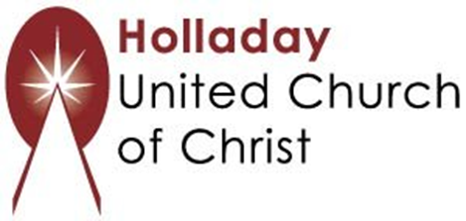
2631 East Murray-Holladay Rd
Holladay, UT 84117 801-277-2631
Rev. Brent Gundlah, Senior Pastor
Rev. Chelsea Page, Associate Pastor

We are a Creation Justice,
Open and Affirming Congregation
of the United Church of Christ.
Participants in Worship:
Reader: Paul Jewell, Slides: Dale Berreth
Music: Steve Ritchey, Eric Richards, Chris Thomas, Jon Green
Video: Jim Bale, Sound: Chuck Dillard

Welcome parents! In-person Sunday School today is canceled due to Omicron. If you would like to join Zoom Sunday School next Sunday at 10 a.m, please email Pastor Chelsea at associatepastor@holladayucc.org. Your child is welcome to pick up books and an art activity from the corner of the sanctuary next to Mama Owl’s Tree of Life. We’re glad you’re here!

PRAYER REQUESTS
The following are offered for your prayers this morning and in the days ahead:
- Prayers of strength and comfort for all those who live in fear of violence.
- Prayers of support and gratitude for our community of caregivers.
- Prayers of healing for all who are facing health issues
- Prayers of comfort for all those in hospice care.

