~LIVESTREAMED TO FACEBOOK~
We are live streaming today’s worship service on Facebook, so we want you to know that your presence here today is your agreement and consent to being part of that recording.

~Please continue wearing your mask while in the Sanctuary~
~Offering plates will be located at the back of the Sanctuary~

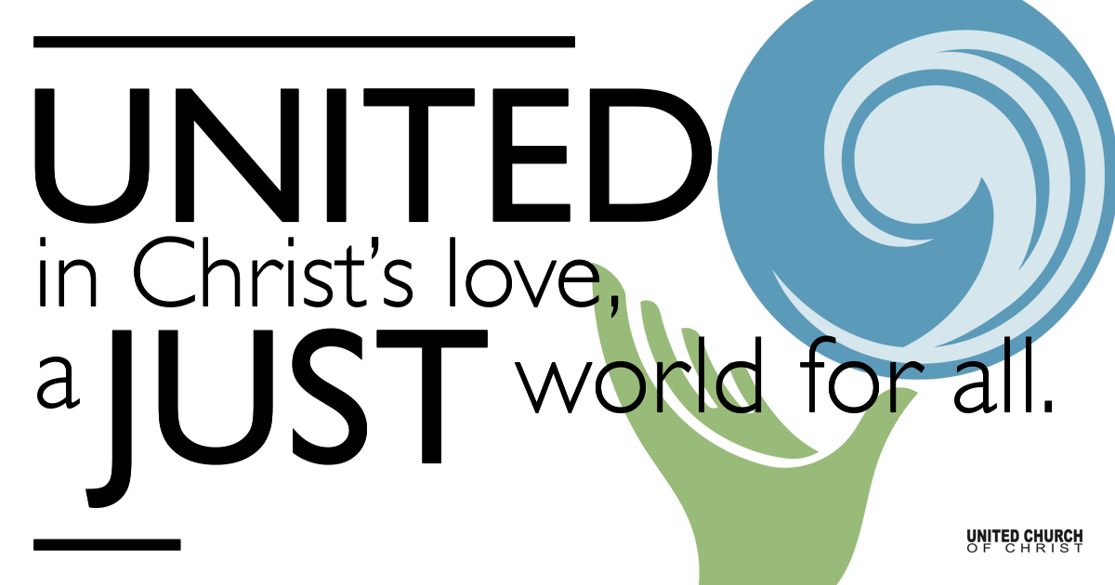
Silent Meditation

February 6, 2022

Fifth Sunday after the Epiphany
Calling
“If God gives you something you can do, why in God's name wouldn't you do it?” - Stephen King

Prelude “Where He Leads Me” Ernest W. Blandy

Welcome to Worship
One: Whoever you are and wherever you are on life’s journey,
ALL: We welcome you here.

Opening Comments

Entrance of Light & Ringing of the Bell

Call to Worship (responsively, adapted from UCC Worship Ways)
One: Isaiah was surprised by the Holy One in the Temple - a vision, a call, a response:
All: Here I am: Send me!
One: Paul was surprised by the Spirit at his hateful work— an interruption, a challenge, a response:
All: I received from the Lord the word of grace I now proclaim!
One: Weary fisher folk were surprised by Jesus at their empty boats — a sign, a promise, a response:
All: They left everything to follow!
One: Let us worship the One whose call surprises and challenges us.

Prayer for Illumination
God of steadfast love and never-ending faithfulness, by the power of your Holy Spirit, help us to hear your word and to understand it, so that we may truly live into all that you are calling us towards. Amen.

Scripture First Reading (Isaiah 6:1-8, CEB)

Opening Song “I Have Decided” Elevated Worship arr.
I have decided to follow Jesus (three times)
No turning back, no turning back

Though none go with me, I still will follow (three times)
No turning back, no turning back

Gospel Reading Luke 5:1-11, CEB
One day Jesus was standing beside Lake Gennesaret when the crowd pressed in around him to hear God’s word. Jesus saw two boats sitting by the lake. The fishermen had gone ashore and were washing their nets. Jesus boarded one of the boats, the one that belonged to Simon, then asked him to row out a little distance from the shore. Jesus sat down and taught the crowds from the boat. When he finished speaking to the crowds, he said to Simon, “Row out farther, into the deep water, and drop your nets for a catch.”

Simon replied, “Master, we’ve worked hard all night and caught nothing. But because you say so, I’ll drop the nets.”

So they dropped the nets and their catch was so huge that their nets were splitting. They signaled for their partners in the other boat to come and help them. They filled both boats so full that they were about to sink. When Simon Peter saw the catch, he fell at Jesus’ knees and said, “Leave me, Lord, for I’m a sinner!” Peter and those with him were overcome with

amazement because of the number of fish they caught. James and John, Zebedee’s sons, were Simon’s partners and they were amazed too.

Jesus said to Simon, “Don’t be afraid. From now on, you will be fishing for people.” As soon as they brought the boats to the shore, they left everything and followed Jesus.

(Opening Song continues)
All I am and all I have to bring
I will give to my everything

Reflection Rev. Brent Gundlah

Call to Offering/Prayer of Dedication

Prayers of the Community
(If you would like to offer a prayer of gratitude or concern for someone or some situation please use first names for security. The congregation will respond to each prayerful offering with the following words:
“Together with God, we hear your prayers.”)

Pastoral Prayer

Invitation to Communion

Communion Song “Eat This Bread” Taize

Communion

Jesus Prayer

Words of Mission and Benediction

Closing Song “I Will Follow” Chris Tomlin

Find out More!



holladayucc.org

Scan to Give & Connect with Us


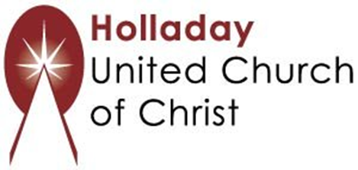
2631 East Murray-Holladay Rd
Holladay, UT 84117 801-277-2631
Rev. Brent Gundlah, Senior Pastor
Rev. Chelsea Page, Associate Pastor

We are a Creation Justice,
Open and Affirming Congregation
of the United Church of Christ.
Participants in Worship:
Reader: Tom Sturgeon, Slides: Dale Berreth, Video: Jim Bale
Music: Carl Adams, Amy Boettger, Mark Dazley, Jani Gamble, Jon Green,
Tom Klassen, Sound: Connie Nomann

Welcome parents! In-person Sunday School today is canceled due to Omicron. If you would like to join Zoom Sunday School next Sunday at 10 a.m, please email Pastor Chelsea at associatepastor@holladayucc.org. Your child is welcome to pick up books and an art activity from the corner of the sanctuary next to Mama Owl’s Tree of Life. We’re glad you’re here!

PRAYER REQUESTS
The following are offered for your prayers this morning and in the days ahead:
- Prayers of strength and comfort for all those who live in fear of violence.
- Prayers of support and gratitude for our community of caregivers.
- Prayers of healing for all who are facing health issues
- Prayers of comfort for all those in hospice care.

