~LIVESTREAMED TO FACEBOOK~
We are live streaming today’s worship service on Facebook, so we want you to know that your presence here today is your agreement and consent to being part of that recording.

~Please continue wearing your mask while in the Sanctuary~
~Offering plates will be located at the back of the Sanctuary~

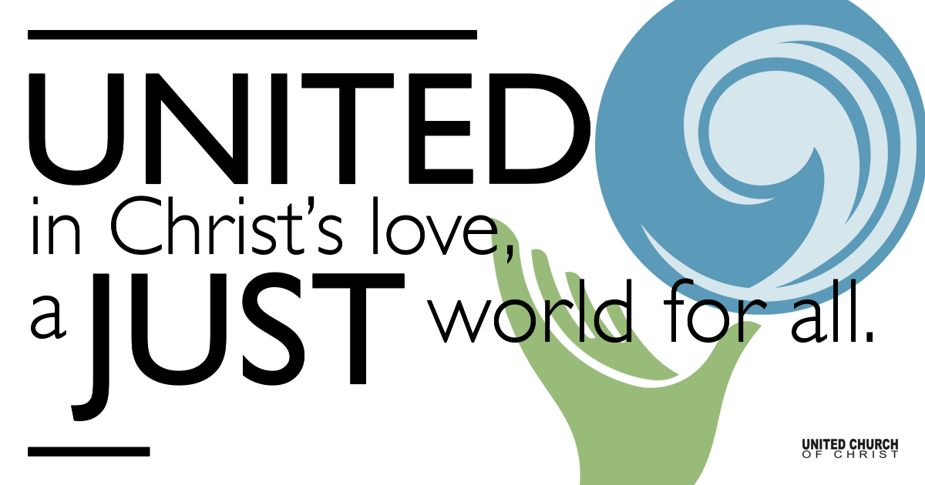
Silent Meditation

February 13, 2022

Sixth Sunday after the Epiphany
Blessing and Woes
“When we lose one blessing, another is often most unexpectedly given in its place.” ― C.S. Lewis

Prelude “Pie Jesu, Requiem” Sondheim

Welcome to Worship
One: Whoever you are and wherever you are on life’s journey,
ALL: We welcome you here.

Opening Comments

Ringing of the Bell

Call to Worship (responsively, from UCC Worship Ways)
One: Blessed are you who are poor, for yours is the kingdom of God.
All: We are each a child of God. No matter who we are, or where we are on life’s journey, we are blessed.
One: Blessed are you who are hungry now, for you will be filled.
All: We come to worship the God who feeds us, who fills us, and who blesses us.
One: Blessed are you who weep now, for you will laugh.
All: Let us rejoice in the love of God, and worship our God together in prayer, song, and praise.

Opening Song “People Get Ready” Curtis Mayfield

Prayer for Illumination

Scripture Jeremiah 17:5-10 - Common English Bible
The Lord proclaims: Cursed are those who trust in mere humans, who depend on human strength and turn their hearts from the Lord.
They will be like a desert shrub that doesn’t know when relief comes. They will live in the parched places of the wilderness, in a barren land where no one survives.
Happy are those who trust in the Lord, who rely on the Lord.
They will be like trees planted by the streams, whose roots reach down to the water. They won’t fear drought when it comes; their leaves will remain green. They won’t be stressed in the time of drought or fail to bear fruit.
The most cunning heart— it’s beyond help. Who can figure it out?
I, the Lord, probe the heart and discern hidden motives, to give everyone what they deserve, the consequences of their deeds.

Luke 6: 17-26 - New Revised Standard Version
He came down with them and stood on a level place, with a great crowd of his disciples and a great multitude of people from all Judea, Jerusalem, and the coast of Tyre and Sidon.
They had come to hear him and to be healed of their diseases; and those who were troubled with unclean spirits were cured.
And all in the crowd were trying to touch him, for power came out from him and healed all of them.

Then he looked up at his disciples and said:
“Blessed are you who are poor, for yours is the kingdom of God.
“Blessed are you who are hungry now, for you will be filled.
“Blessed are you who weep now, for you will laugh.
“Blessed are you when people hate you, and when they exclude you, revile you, and defame you on account of the Son of Man.
Rejoice in that day and leap for joy, for surely your reward is great in heaven; for that is what their ancestors did to the prophets.

“But woe to you who are rich, for you have received your consolation.
“Woe to you who are full now, for you will be hungry.
“Woe to you who are laughing now, for you will mourn and weep.
“Woe to you when all speak well of you, for that is what their ancestors did to the false prophets.

Reflection “Complicated Blessings” Rev. Brent Gundlah

Call to Offering/Prayer of Dedication

Prayers of the Community
(If you would like to offer a prayer of gratitude or concern for someone or some situation please use first names for security. The congregation will respond to each prayerful offering with the following words:
“Together with God, we hear your prayers.”)

Pastoral Prayer

Jesus Prayer

Our Creator who is in heaven,
Hallowed be Your name,
Your reign come, Your will be done,
On earth as it is in heaven,
Give us this day our daily bread,
And forgive us our debts as we forgive our debtors,
And lead us not into temptation, but deliver us from evil,
For Yours is the reign, the power, and glory for ever. Amen.

Words of Mission and Benediction

Closing Song “Stand Up” Cynthia Erivo & Joshuah Campbell

Find out More!



holladayucc.org

Scan to Give & Connect with Us



2631 East Murray-Holladay Rd
Holladay, UT 84117 801-277-2631
Rev. Brent Gundlah, Senior Pastor
Rev. Chelsea Page, Associate Pastor

We are a Creation Justice,
Open and Affirming Congregation
of the United Church of Christ.
Participants in Worship:
Reader: Ruby Ostermann, Slides: Kyla Asmar, Video: Jim Bale
Music: Carl Adams, Mark Dazley, Kelly Martin, Cory McCann, Tom Klassen

Welcome parents! In-person Sunday School today is canceled due to Omicron. If you would like to join Zoom Sunday School next Sunday at 10 a.m, please email Pastor Chelsea at associatepastor@holladayucc.org. Your child is welcome to pick up books and an art activity from the corner of the sanctuary next to Mama Owl’s Tree of Life. We’re glad you’re here!

Giddy up Pardners! The Holladay Preschool Benefit Bash is on!
After talkin’ to the docs and hearing from the folks in our community, the Holladay Preschool Board has decided to change the date and hold our annual Benefit Bash on Friday, March 25th. This will provide us with the time needed to hold a safe, responsible, back slappin’ barn buster. The event will be held at the Garden Place at This is the Place Heritage Park, a perfect spot to enjoy good grub, spirits and bid on ace-high silent and live auction items. Git yer’ tickets at https://HPS.givesmart.com. If ya’ll can’t make it, you can always sponsor a table for our teachers. It would be mighty generous and we will recognize your donation at the Bash!

