~LIVESTREAMED TO FACEBOOK~
We are live streaming today’s worship service on Facebook, so we want you to know that your presence here today is your agreement and consent to being part of that recording.

~Please continue wearing your mask while in the Sanctuary~
~Offering plates will be located at the back of the Sanctuary~

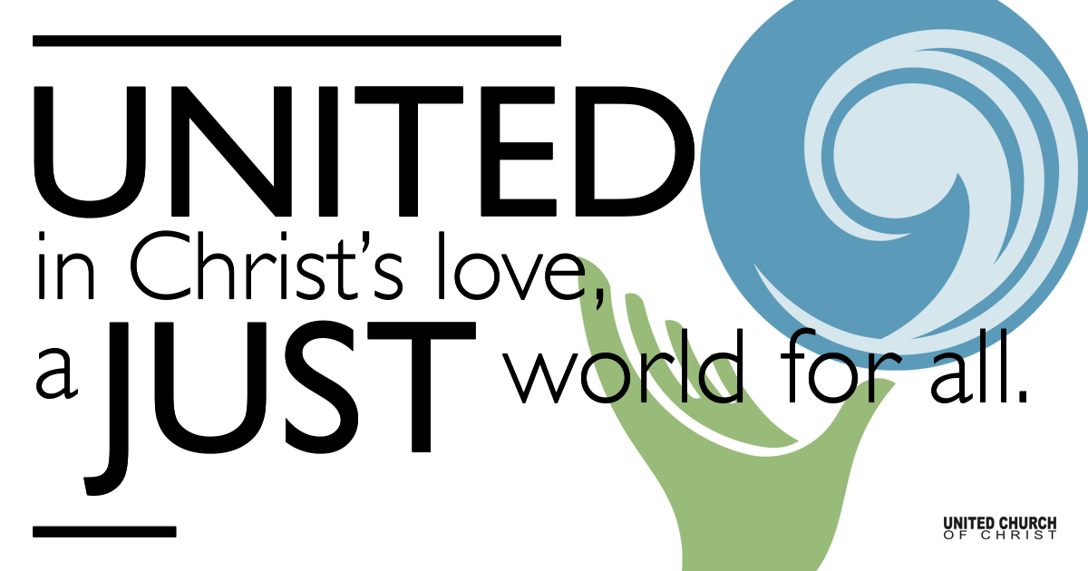
Silent Meditation

February 27, 2022

Transfiguration Sunday
Change
Where woundedness can be refined into beauty a wonderful transfiguration takes place.” ― John O'Donohue

Prelude “I Am the Light of the World” Jim Strathdee

Welcome to Worship
One: Whoever you are and wherever you are on life’s journey,
ALL: We welcome you here.

Opening Comments

Ringing of the Bell

Call to Worship (from UCC Worship Ways)
One: Something drew us together this morning
All: Something we can’t name but which we experience in worship
One: Some holy mystery we call God
All: Some sacred calling we hear in the life of Jesus
One: Some indescribable hope we feel when we gather in the Spirit
All: May our experience of the Divine transform our doubts and fears and prepare us to love the world.

Opening Song “Imago Dei” Jill Kirsten Warner (SPP#118)

Prayer for Illumination

First Reading Exodus 34:29-35, NRSV

Moses came down from Mount Sinai. As he came down from the mountain with the two tablets of the covenant in his hand, Moses did not know that the skin of his face shone because he had been talking with God. When Aaron and all the Israelites saw Moses, the skin of his face was shining, and they were afraid to come near him. But Moses called to them; and Aaron and all the leaders of the congregation returned to him, and Moses spoke with them. Afterward all the Israelites came near, and he gave them in commandment all that the Lord had spoken with him on Mount Sinai. When Moses had finished speaking with them, he put a veil on his face; but whenever Moses went in before the Lord to speak with him, he would take the veil off, until he came out; and when he came out, and told the Israelites what he had been commanded, the Israelites would see the face of Moses, that the skin of his face was shining; and Moses would put the veil on his face again, until he went in to speak with him.

Gospel Reading Luke 9:28-36, NRSV

Now about eight days after these sayings Jesus took with him Peter and John and James, and went up on the mountain to pray. And while he was praying, the appearance of his face changed, and his clothes became dazzling white. Suddenly they saw two men, Moses and Elijah, talking to him. They appeared in glory and were speaking of his departure, which he was about to accomplish at Jerusalem. Now Peter and his companions were weighed down with sleep; but since they had stayed awake, they saw his glory and the two men who stood with him. Just as they were leaving him, Peter said to Jesus, “Master, it is good for us to be here; let us make three dwellings, one for you, one for Moses, and one for Elijah”—not knowing what he said. While he was saying this, a cloud came and overshadowed them; and they were terrified as they entered the cloud. Then from the cloud came a voice that said, “This is my Son, my Chosen; listen to him!” When the voice had spoken, Jesus was found alone. And they kept silent and in those days told no one any of the things they had seen.
On the next day, when they had come down from the mountain, a great crowd met him. Just then a man from the crowd shouted, “Teacher, I beg you to look at my son; he is my only child. Suddenly a spirit seizes him, and all at once he shrieks. It convulses him until he foams at the mouth; it mauls him and will scarcely leave him. I begged your disciples to cast it out, but they could not.” Jesus answered, “You faithless and perverse generation, how much longer must I be with you and bear with you? Bring your son here.” While he was coming, the demon dashed him to the ground in convulsions. But Jesus rebuked the unclean spirit, healed the boy, and gave him back to his father. And all were astounded at the greatness of God.

Reflection “Turn and Face the Strange”

Call to Offering/Prayer of Dedication

Prayers of the Community
(If you would like to offer a prayer of gratitude or concern for someone or some situation please use first names only. The congregation will respond to each prayerful offering with the following words:
“Together with God, we hear your prayers.”)

Pastoral Prayer

Jesus Prayer

Words of Mission and Benediction

Closing Song “Amazing Grace/Peaceful Easy Feeling”

Find out More!



holladayucc.org

Scan to Give & Connect with Us


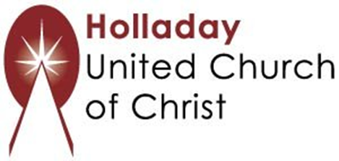
2631 East Murray-Holladay Rd
Holladay, UT 84117 801-277-2631
Rev. Brent Gundlah, Senior Pastor
Rev. Chelsea Page, Associate Pastor

We are a Creation Justice,
Open and Affirming Congregation
of the United Church of Christ.
Participants in Worship:
Reader: Dennis Bayes, Slides: Gary Duran
Sound: Winston Gamble, Video: Jim Bale, Music: Holy House Band

Support Resources

Caring Ministry:
For short term help with meals and for prayers offered by this group. Please contact Becky Burrage (801 598 5377) or Keith Guernsey (801 598 5394); keithbecky@gmail.com.

Stephen Ministry:
For someone to listen and talk with, for a couple of visits, or for a longer period of time. Please contact Kathy Gamble (801 651 1161, cjkbgamble@gmail.com), Jan Foutz ( 801 556 8374, janfoutz@msn.com), or Keith Guernsey (801 598 5394, keithbecky@gmail.com)

