~LIVESTREAMED TO FACEBOOK~
We are live streaming today’s worship service on Facebook, so we want you to know that your presence here today is your agreement and consent to being part of that recording.

~Please continue wearing your mask while in the Sanctuary~
~Offering plates will be located at the back of the Sanctuary~

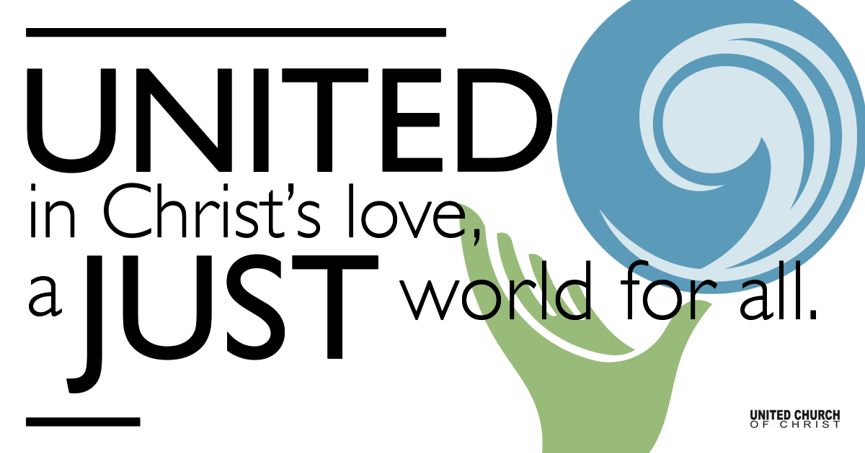
Silent Meditation

March 13, 2022

New Member Sunday
Second Sunday in Lent
Little Seeds: Fertile Offerings
"God made a covenant with us, and God wants our relationships with one another to reflect that covenant. That’s why marriage, friendship, life in community are all ways to give visibility to God’s faithfulness in our lives together.” ~ Henri Nouwen

Prelude “Now Thank We All Our God” Bach

Welcome to Worship
One: Whoever you are and wherever you are on life’s journey,
ALL: We welcome you here.

Entrance of Light & Ringing of the Bell

Call to Worship (by Rev. Michael Anthony Howard)
One: God desires to gather us
Many: She gathers us together
One: Her wings spread out before us
Many: Her presence, all around us
One: To nurture is her nature
Many: To mother is her gift
One: For our safety, she reaches
Many: For our good, she moves
One: Sheltering over us
Many: She is our fortress
One: Deep in her underwing
Many: She is our strength
One: Because of us, she is wounded
Many: By her wounds we are saved
One: Until all fear is gone
Many: Until the work is finished
One: In her, we find our justice
Many: In her, we find our peace.

COVENANT OF MEMBERSHIP

Invitation

Introduction of New Members
Pegasus Collonge, Karen Dorman, Daniel Haas, Tina Huynh Duran, Gary Duran, Bri Higgins, Alle Maulden, Christopher Thomas

Sentences

Questions of Candidates

Welcome and Reception
Pastor: Let us, the members and friends of Holladay United Church of Christ, express our welcome and affirm our mutual ministry in Christ.
All: We welcome you with joy in the common life of this church. We promise you our friendship and prayers as we share the hopes and labors of the Body of Christ. Together may we live in the unity of the Spirit, building one another up in love, sharing in the life and worship of the community and serving the world for Jesus’ sake. Amen.

Greeting of Christian Love

Passing of the Peace

Children’s Chat & Blessing Rev. Chelsea Page

Centering Song “Jesu Joy of Man’s Desire” Bach

Prayer for Illumination

First Reading Genesis 15:1-12, 17-18 NRSV

Centering Song Reprise “Jesu Joy of Man’s Desire” Bach

Gospel Reading Luke 13:31-35 NRSV

Reflection “Covenant”

Call to Offering/Prayer of Dedication

Announcements

Prayers of the Community
(If you would like to offer a prayer of gratitude or concern for someone or some situation please use first names only. The congregation will respond to each prayerful offering with the following words:
“Together with God, we hear your prayers.”)

Pastoral Prayer

Jesus Prayer

Words of Mission and Benediction (from the Church of Scotland)
One: Get up, go on your way!
All: Faith makes us fit to heal!
One: The world now needs to know
All: How Christ is flesh for all
One: As creatures of God's love
All: tread lightly, and with joy
One: Trust God, learn from the Earth
All: We welcome life, where we find home!
One: Go in peace! Amen and amen.

Closing Song “Simple Gifts” arr. Michael Mauldin

Find out More!



holladayucc.org

Scan to Give & Connect with Us


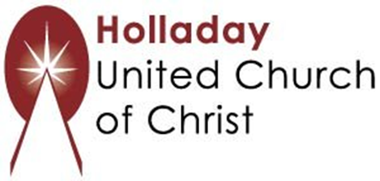
2631 East Murray-Holladay Rd
Holladay, UT 84117 801-277-2631
Rev. Brent Gundlah, Senior Pastor
Rev. Chelsea Page, Associate Pastor

We are a Creation Justice,
Open and Affirming Congregation
of the United Church of Christ.
Participants in Worship:
Reader: Heather Bertotti Sarin, Slides: Gary Duran, Video: Jim Bale
Music: HUCC Choir, Children’s Chat: Rev. Chelsea Page

Support Resources

Caring Ministry:
For short term help with meals and for prayers offered by this group. Please contact Becky Burrage (801 598 5377) or Keith Guernsey (801 598 5394); keithbecky@gmail.com.

Stephen Ministry:
For someone to listen and talk with, for a couple of visits, or for a longer period of time. Please contact Kathy Gamble (801 651 1161, cjkbgamble@gmail.com), Jan Foutz ( 801 556 8374, janfoutz@msn.com), or Keith Guernsey (801 598 5394, keithbecky@gmail.com)

