~LIVESTREAMED TO FACEBOOK~
We are live streaming today’s worship service on Facebook, so we want you to know that your presence here today is your agreement and consent to being part of that recording.

~Please continue wearing your mask while in the Sanctuary~
~Offering plates will be located at the back of the Sanctuary~

↑(Indicates a time when you are requested to stand in body or spirit.)

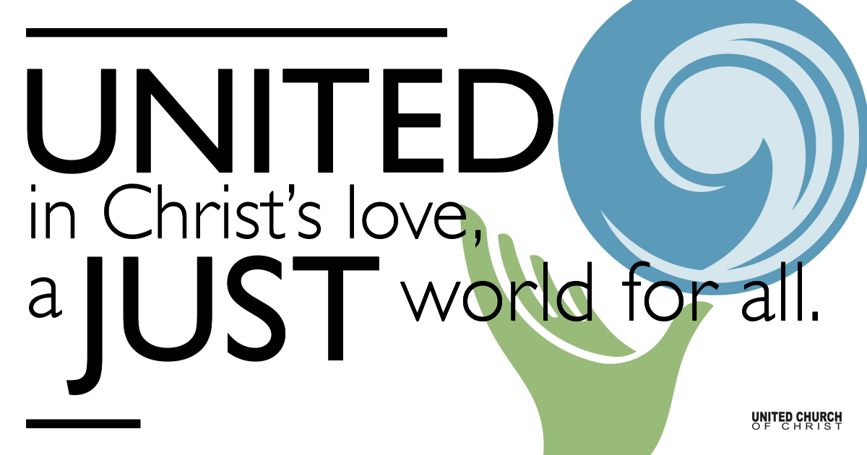
Silent Meditation

March 27, 2022

Fourth Sunday in Lent
Tend Your Garden
“God is our last hope because we are God's first love.”
~Jürgen Moltmann

Prelude “Like a Healing Stream” Bruce Harding

Welcome to Worship
One: Whoever you are and wherever you are on life’s journey,
ALL: We welcome you here.

Opening Comments

Entrance of Light & Ringing of the Bell

Call to Worship (Inspired by Psalm 32, Rev. Michelle L. Torigian)
One: Happy are those who experience the grace of God
Many: Who find forgiveness and mercy from the Holy One.
One: Happy are those who experience the steadfast love of God
Many: Who find peace even in times of trial.
One: Happy are those who experience rest in God
Many: Who find sabbath to renew their spirit.

↑Passing of the Peace
Pastor: May the peace of Christ be with you.
All: And also with you.
Pastor: Let us now greet one another with a sign of peace.

Children’s Chat & Blessing Rev. Chelsea Page

↑Centering Song “What Wondrous Love Is This” NCH#223
Verse 1: What wondrous love is this, O my soul! O my soul!
What wondrous love is this, O my soul!
What wondrous love is this that Christ should come in bliss to bear the heavy cross for my soul, for my soul, to bear the heavy cross for my soul.

Verse 2: To God and to the Lamb I will sing, I will sing,
To God and to the Lamb, I will sing;
to God and to the Lamb, who is the great I Am
While millions join the theme, I will sing, I will sing;
while millions join the theme, I will sing.

Prayer for Illumination

First Reading (Joshua 5: 9-12, NRSV)
The Lord said to Joshua, “Today I have rolled away from you the disgrace of Egypt.” And so that place is called Gilgal to this day.
While the Israelites were camped in Gilgal they kept the passover in the evening on the fourteenth day of the month in the plains of Jericho. On the day after the passover, on that very day, they ate the produce of the land, unleavened cakes and parched grain. The manna ceased on the day they ate the produce of the land, and the Israelites no longer had manna; they ate the crops of the land of Canaan that year.

Gospel Reading (Luke 15:1-3, 11b-32, NRSV)

Reflection “God’s First Love”

Call to Offering/Prayer of Dedication

↑Doxology
Praise God from whom all blessings flow;
Praise God, all creatures here below;
Praise God for all that love has done;
Creator, Christ, and Spirit, One. Amen.

Announcements

Prayers of the Community
(If you would like to offer a prayer of gratitude or concern for someone or some situation please use first names for security. The congregation will respond to each prayerful offering with the following words:
“Together with God, we hear your prayers.”)

Pastoral Prayer

Jesus Prayer
Our Creator who is in heaven,
Hallowed be Your name,
Your reign come, Your will be done,
On earth as it is in heaven,
Give us this day our daily bread,
And forgive us our debts as we forgive our debtors,
And lead us not into temptation, but deliver us from evil,
For Yours is the reign, the power, and glory for ever. Amen.

Words of Mission and Benediction

Closing Song “The King of Glory” Israeli Traditional
Refrain: The King of Glory comes, the nation rejoices
Open the gates before him; lift up your voices

Parents, please collect your child(ren) from their teachers in McMullen Hall. Thank you!

Find out More!



holladayucc.org

Scan to Give & Connect with Us



2631 East Murray-Holladay Rd
Holladay, UT 84117 801-277-2631
Rev. Brent Gundlah, Senior Pastor
Rev. Chelsea Page, Associate Pastor

We are a Creation Justice,
Open and Affirming Congregation
of the United Church of Christ.
Participants in Worship:
Reader: Tom Sturgeon, Slides: Kyla Asmar, Video: Jim Bale
Music: Holy House Band, Children’s Chat: Chelsea Page

Welcome parents! We are glad you and your child(ren) are here. Please begin worship seated together as a family. After Children’s Chat, children will walk to Sunday School with their teachers. We have classes for grades PK-2 and 3-6. Please pick up your child(ren) from McMullen Hall promptly after the service. Thank you!

