~LIVESTREAMED TO FACEBOOK~
We are live streaming today’s worship service on Facebook, so we want you to know that your presence here today is your agreement and consent to being part of that recording.

~Please continue wearing your mask while in the Sanctuary~
~Offering plates will be located at the back of the Sanctuary~

↑(Indicates a time when you are requested to stand in body or spirit.)

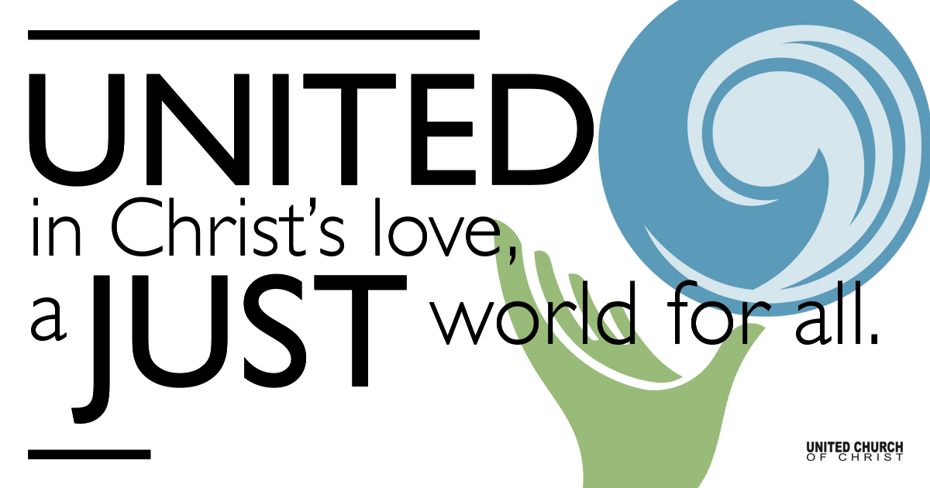
Silent Meditation

April 3, 2022

Fifth Sunday in Lent
Little Seeds: Water Hope
“The one thing we need more than hope is action. Once we start to act, hope is everywhere. So instead of looking for hope, look for action. Then, and only then, hope will come.” - Greta Thunberg

Prelude “Down to the River” Mandy Lynn Danzig

Welcome to Worship
One: Whoever you are and wherever you are on life’s journey,
ALL: We welcome you here.

Entrance of Light & Ringing of the Bell

Call to Worship
One: Water is transformation. Water forms a passageway from chaos to order and death to life.
All: God uses the waters of chaos to create order.
One: God uses water to bring the people from bondage to freedom.
All: God uses water to turn a desolate place into a place of life.

One: We gather today to water the seeds of hope that are present within and all around us.
All: Let us worship God!

Holy Communion
(Prayers adapted from Carolyn Brown and Maren Tirabassi)

Communion Song “Poor Wayfaring Stranger” Traditional

Passing of the Peace

Children’s Chat & Blessing Ruby Hammel

Prayer for Illumination (Adapted from Rev. Dr. Cheryl A. Lindsay)

Centering Song “We Shall Overcome” Pete Seeger & Lee Hays

We shall overcome, we shall overcome, we shall overcome some day;
Oh, deep in my heart, I do believe, we shall overcome some day.

We are not afraid . . .
We'll walk hand in hand . . .
We shall live in peace . . .

Scripture Isaiah 43:16-21 NRSV

Gospel John 12:1-8 NRSV

Reflection “Letting Go” Rev. Chelsea Page

Call to Offering (Adapted from Rev. Dr. Cheryl A. Lindsay)

One Great Hour of Sharing

Prayer of Dedication (by Rev. Dr. Cheryl A. Lindsay)

Announcements

Prayers of the Community
(If you would like to offer a prayer of gratitude or concern for someone or some situation please use first names for security. The congregation will respond to each prayerful offering with the following words:
“Together with God, we hear your prayers.”)

Pastoral Prayer (By Nadia Bolz-Weber)

Jesus Prayer
Our Creator who is in heaven,
Hallowed be Your name,
Your reign come, Your will be done,
On earth as it is in heaven,
Give us this day our daily bread,
And forgive us our debts as we forgive our debtors,
And lead us not into temptation, but deliver us from evil,
For Yours is the reign, the power, and glory for ever. Amen.

Words of Mission and Benediction (Adapted from Kathy Bray)

Closing Song “When it Goes” Mandy Lynn Danzig

Parents, please collect your child(ren) from their teachers in McMullen Hall. Thank you!

Find out More!



holladayucc.org

Scan to Give & Connect with Us


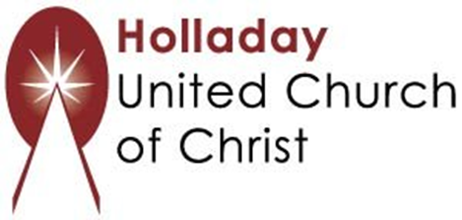
2631 East Murray-Holladay Rd
Holladay, UT 84117 801-277-2631
Rev. Brent Gundlah, Senior Pastor
Rev. Chelsea Page, Associate Pastor

We are a Creation Justice,
Open and Affirming Congregation
of the United Church of Christ.
Participants in Worship:
Reader: Ruby Ostermann, Slides: Dale Berreth, Video: Chuck Dillard
Music: Mandy Danzig, Alisa Bolander, Children’s Chat: Ruby Hammel

Welcome parents! We are glad you and your child(ren) are here. Please begin worship seated together as a family. After Children’s Chat, children will walk to Sunday School with their teachers. We have classes for grades PK-2 and 3-6. Please pick up your child(ren) from McMullen Hall promptly after the service. Thank you!

