~LIVESTREAMED TO FACEBOOK~
~Please continue wearing your mask while in the Sanctuary~
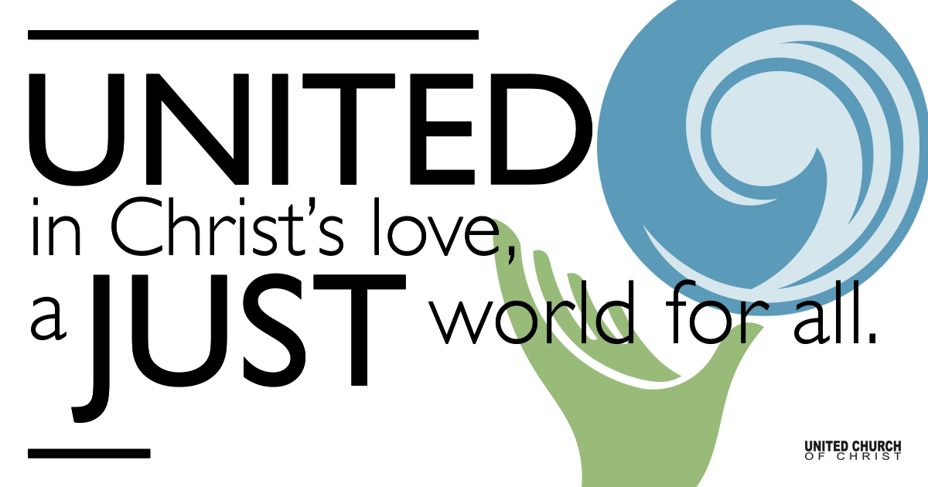

April 14, 2022

Maundy Thursday
Go Underground
Prelude “Loosen Loosen” Aly Halpert

Welcome
I said to my soul, be still, and wait without hope
For hope would be hope for the wrong thing;
wait without love,
For love would be love of the wrong thing;
there is yet faith
But the faith and the love and the hope are all in the waiting.
Wait without thought, for you are not ready for thought:
So the darkness shall be the light, and the stillness the dancing.
Whisper of running streams, and winter lightning.
The wild thyme unseen and the wild strawberry,
The laughter in the garden, echoed ecstasy
Not lost, but requiring, pointing to the agony
Of death and birth. (from T.S. Eliot - from “Four Quartets: East Coker”)

Call to Worship (responsively)
One: Come, let us join at the table.
Many: Let us join at the table. Let us be set free.
One: Come, a place is set for each of us.
Many: Let us join at the table. Let us be set free.
One: Come, join the misfits, thieves, and liars.
Many: Let us join at the table. Let us be set free.
One: Come, young and old, from near or far.
Many: Let us join at the table. Let us be set free.
One: Come, where shame is no longer welcome.
Many: Let us join at the table. Let us be set free.
One: Come, where forgiveness and mercy triumph.
Many: Let us join at the table. Let us be set free.
(from Rev. Michael Anthony Howard, UCC Worship Ways)

Lighting of Candles

Music “Within Our Darkest Night” Taize Community
Within our darkest night you kindle a fire
that never dies away, never dies away

Prayer of Confession (responsively)
All: For all the ways in which we have betrayed you, hurt one another and harmed your creation, forgive us, O God.

Moment of Silent Reflection

Assurance of Forgiveness

WITH CHRIST AT THE LAST SUPPER

Invitation

Gospel Reading (Luke 22:14-23)

Prayer of Consecration

Distribution of Elements

Communion Song “One Bread, One Body” John B. Foley

Prayer of Thanksgiving

WITH CHRIST IN THE GARDEN OF PRAYER

Call to Prayer

Moment of Silence

Pastoral Prayer

Lord’s Prayer

Music “Be Still” Simon De Voil
Be still and know that I am God/Love/Peace

WITH CHRIST IN THE DARK NIGHT OF BETRAYAL

Prayer of Illumination

The Readings and Extinguishing of the Candles
Matthew 26:20-25 (The Shadow of Betrayal)
Matthew 26:31-35 (The Shadow of Desertion)
Luke 22:39-44 (Agony of the Soul)

Music “Watch and Pray” Taize
Stay with me, remain here with me
Watch and pray, watch and pray

Mark 14:32-41 (Unshared Vigil)
John 17:1-6 (“Father, the Hour Has Come”)
John 17:15-22 (“That They May All Be One”)

Music “Were You There” Spiritual
Were you there when they crucified my Lord? (repeat)
Oh sometimes it causes me to tremble, tremble, tremble
Were you there when they crucified my Lord?
Were you there when they nailed Him to the tree?
Were you there when they laid Him in the tomb?
Were you there when God wept at Mary’s cry?

John 18:1-5 (Arrest in the Garden)
Mark 15:16-20 (Shadow of the Cross)
John 1:1-4, 14,10,12, 3:19 (The Word Was God)

Music “What Wondrous Love Is This” trad, arr. Sounds Like Reign

Moment of Silent Reflection & Departure

Find out More!



holladayucc.org

Scan to Give & Connect with Us


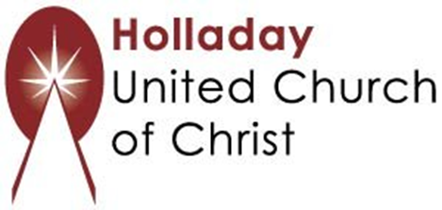
2631 East Murray-Holladay Rd
Holladay, UT 84117 801-277-2631
Rev. Brent Gundlah, Senior Pastor
Rev. Chelsea Page, Associate Pastor

We are a Creation Justice,
Open and Affirming Congregation
of the United Church of Christ.
Participants in Worship:
Readers: Dennis Bayes, Gary Duran, Tina Huynh Duran,
Pat Gamble Hovey, Paul & Teri Jewell
Music: Jani Gamble & Robb Carlson, Sound: Connie Nomann

