~LIVESTREAMED TO FACEBOOK~
We are live streaming today’s worship service on Facebook, so we want you to know that your presence here today is your agreement and consent to being part of that recording.

~Please continue wearing your mask while in the Sanctuary~
~Offering plates will be located at the back of the Sanctuary~

↑(Indicates a time when you are requested to stand in body or spirit.)

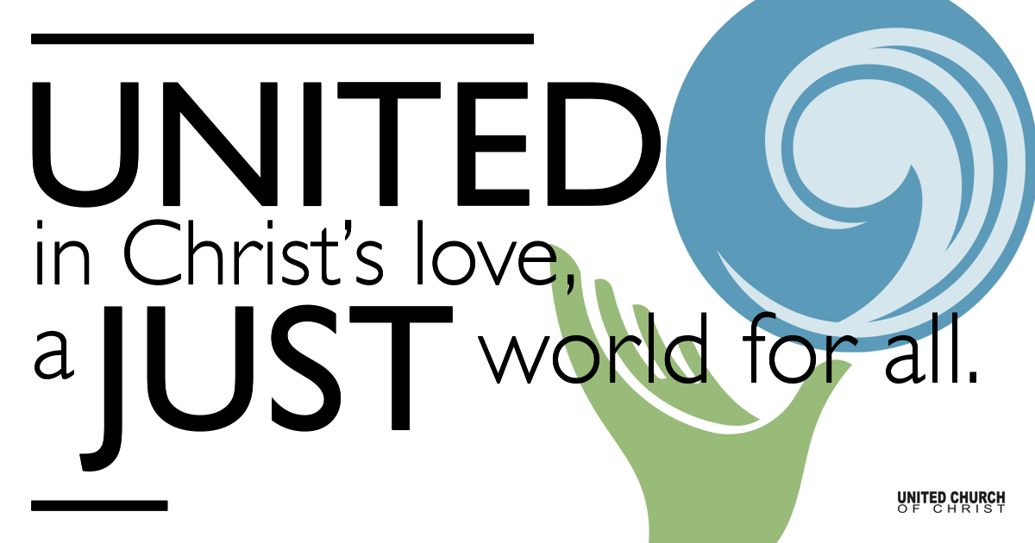
Silent Meditation

April 17, 2022

Easter Sunday
Life Blooms
We trust in the future we cannot see and do only know because we have celebrated the death and resurrection of Jesus year after year. In His life we rest our own. ― Joan Chittister

Prelude “Easter Carol” Arr. by Patti Drennan

Welcome to Worship
One: Whoever you are and wherever you are on life’s journey,
ALL: We welcome you here.

Opening Comments

Entrance of Light & Ringing of the Bell

Call to Worship (Psalm 118, responsively):
One: O give thanks to the Lord, for he is good; his steadfast love endures forever!
All: The Lord is my strength and my might; he has become my salvation!
One: I shall not die, but I shall live, and recount the deeds of the Lord!

All: Open to me the gates of righteousness,
that I may enter through them and give thanks to the Lord!
One: The stone that the builders rejected has become the chief cornerstone!
All: This is the day that the Lord has made; let us rejoice and be glad in it!

↑Opening Song “Christ the Lord is Risen Today” NCH 233

Christ the Lord is risen today, Alleluia!
Mortal tongues and angels say, Alleluia!
Raise your joys and triumphs high, Alleluia!
Sing, glad heavens, and earth reply, Alleluia!

Let the Victor’s people sing, Alleluia!
Where, O death, in now your sting? Alleluia!
Dying once, Christ lives to save, Alleluia!
Where your victory, O grave?

Love's redeeming work is done, Alleluia!
Fought the fight, the battle won, Alleluia!
Death in vain forbids Christ rise, Alleluia!
God has opened paradise, Alleluia!

Soar we now where Christ has led, Alleluia!
Following our exalted Head, Alleluia!
Made like Christ, like Chris we rise, Alleluia!
Ours the cross, the grave, the skies, Alleluia!

↑Passing of the Peace

Flowering Cross

Children’s Chat

Prayer for Illumination

First Reading (Isaiah 65:17-25, NRSV)

Choir Song “Christ is Arisen, Indeed!” Natalie Sleeth

Gospel Reading (John 20:1-18, NRSV)

Reflection

Call to Offering/Prayer of Dedication

↑Doxology
Praise God from whom all blessings flow;
Praise God, all creatures here below;
Praise God for all that love has done;
Creator, Christ, and Spirit, One.

Prayers of the Community
(If you would like to offer a prayer of gratitude or concern for someone or some situation please use first names for security. The congregation will respond to each prayerful offering with the following words:
“Together with God, we hear your prayers.”)

Pastoral Prayer

Jesus Prayer
Our Creator who is in heaven,
Hallowed be Your name,
Your reign come, Your will be done,
On earth as it is in heaven,
Give us this day our daily bread,
And forgive us our debts as we forgive our debtors,
And lead us not into temptation, but deliver us from evil,
For Yours is the reign, the power, and glory for ever. Amen.

Words of Mission and Benediction

Postlude “Hallelujah Chorus” GF Handel

Find out More!



holladayucc.org

Scan to Give & Connect with Us


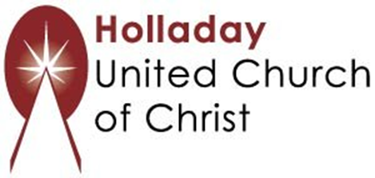
2631 East Murray-Holladay Rd
Holladay, UT 84117 801-277-2631
Rev. Brent Gundlah, Senior Pastor
Rev. Chelsea Page, Associate Pastor

We are a Creation Justice,
Open and Affirming Congregation
of the United Church of Christ.
Participants in Worship:
Reader: Debbie Wilkerson, Slides: Roger Lamoni, Video: Jim Bale
Music: HUCC Choir

Welcome parents! We are glad you and your child(ren) are here. Please begin worship seated together as a family. After Children’s Chat, children will walk to Sunday School with their teachers. We have classes for grades PK-2 and 3-6. Please pick up your child(ren) from McMullen Hall promptly after the service. Thank you!

