~LIVESTREAMED TO FACEBOOK~
We are live streaming today’s worship service on Facebook, so we want you to know that your presence here today is your agreement and consent to being part of that recording.

~Please continue wearing your mask while in the Sanctuary~
~Offering plates will be located at the back of the Sanctuary~

↑(Indicates a time when you are requested to stand in body or spirit.)

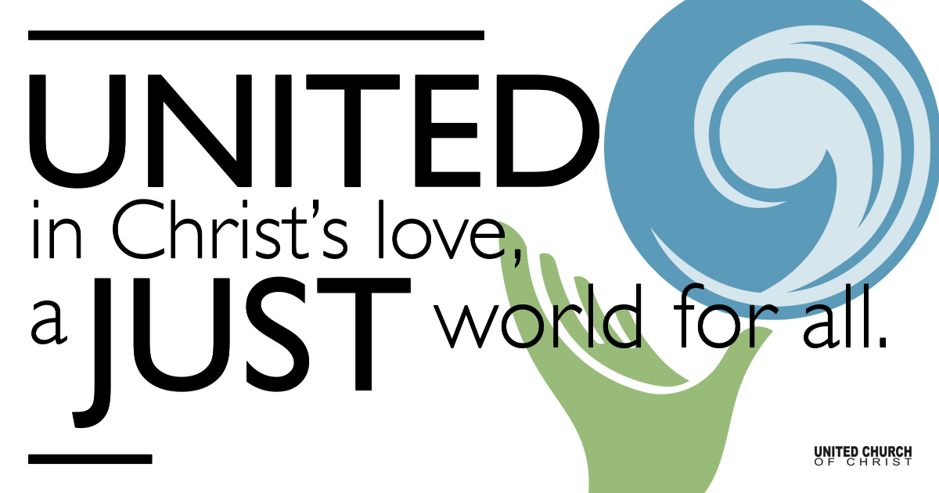
Silent Meditation

April 24, 2022

Earth Day
Everyday Prophets
“The decisions we make today should result in a sustainable world seven generations into the future.” ~The Seventh Generation Principle, ancient Haudenosaunee (Iroquois) philosophy

Prelude “Morningstar” Mary Susan Gast (SPP#2)

Welcome to Worship
One: Whoever you are and wherever you are on life’s journey,
ALL: We welcome you here.

Opening Comments

Entrance of Light & Ringing of the Bell

Call to Worship
One: What Is A Prophet? We answer this in many ways.
All: A prophet can be a truth-teller. A prophet can be a disrupter of the status quo.
One: A prophet can be a seeker of justice, a faithful and faith-filled visionary in the bleakest of times.
All: Right now, in this climate emergency, we need prophets.
One: We need prophets willing to confront those in power, willing to speak up and speak out. But here’s the catch. We cannot wait for others to be the prophets that the world needed yesterday.
All: We have to find the prophet in each of us. We have to be the ones to step forward and answer the call.
One: Together we are more than enough.
(From UCC Creation Justice Ministries, movie by Connie Nomann)

↑Passing of the Peace

Children’s Chat & Blessing Linda Hilton
All: Let us join with all creation (Earth) and rejoice!
(All raise up hands in the direction of the children and youth)

Prayer for Illumination

↑Centering Music “It’s a Song of Praise to the Maker” SPP#133

Centering Reading Psalm 8

Scripture Micah 6:8 (Common English Bible)
You have been told, human one, what is good and what the Lord requires from you: to do justice, embrace faithful love, and walk humbly with your God.

John 8:31–32
Jesus said to the Jews who believed in him, “You are truly my disciples if you remain faithful to my teaching. Then you will know the truth, and the truth will set you free.

Reflections from Everyday Prophets
Jo Overton
Christopher Thomas
Jani Gamble

Call to Offering/Prayer of Dedication
One: May we use the world’s resources we need with love, humility, thoughtfulness, without waste.
All: May we live in harmony with the earth
One: May we live together with animals with which we share this planet, being careful not to harm them or their habitats.
All: May we live in harmony with the earth.
One: May we respect the life in our lakes, rivers and oceans, using them with care and being mindful in our efforts not to pollute them.
All: May we live in harmony with the earth
One: May we learn to live within our means, by reducing our waste and continuing to reuse and recycle all that we can.
All: May we live in harmony with the earth
One: May we plan to leave the world in a state that all future generations will be able to enjoy, ensuring that it is filled with resources, life, and kept healthy and clean.
All: May we live in harmony with the earth.

↑Doxology

Announcements

Prayers of the Community and for Creation
(If you would like to offer a prayer of gratitude or concern for someone or some situation please use first names for security. The congregation will respond to each prayerful offering with the following words:
“Together with God, we hear your prayers.”)

Pastoral Prayer (We Hold the Earth Climate Blessing)

Unison Prayer

Words of Mission and Benediction by Diana Smith

Closing Song “Blue Boat Home” Peter Mayer

Find out More!



holladayucc.org

Scan to Give & Connect with Us


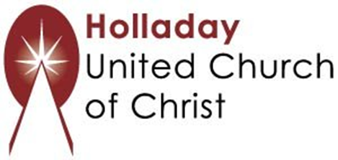
2631 East Murray-Holladay Rd
Holladay, UT 84117 801-277-2631
Rev. Brent Gundlah, Senior Pastor
Rev. Chelsea Page, Associate Pastor

We are a Creation Justice,
Open and Affirming Congregation
of the United Church of Christ.
Participants in Worship:
Slides: Kyla Asmar and Connie Nomann, Video: Brent Gundlah
Music: Holy House Band, Children’s Chat: Linda Hilton
Reader: Pat Gamble Hovey

Welcome parents! We are glad you and your child(ren) are here. Please begin worship seated together as a family. After Children’s Chat, children will walk to Sunday School with their teachers. We have classes for grades PK-2 and 3-6. Please pick up your child(ren) from McMullen Hall promptly after the service. Thank you!

