~LIVESTREAMED TO FACEBOOK~
We are live streaming today’s worship service on Facebook, so we want you to know that your presence here today is your agreement and consent to being part of that recording.

~Masks are optional in the building~

↑(Indicates a time when you are requested to stand in body or spirit.)

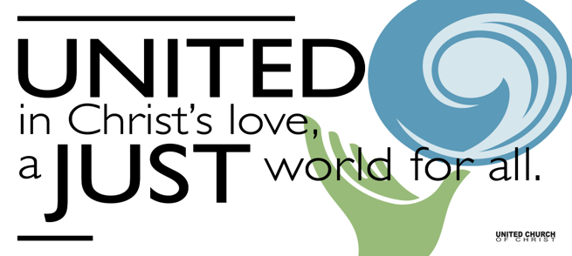
Silent Meditation

November 6, 2022
Twenty-second Sunday
after Pentecost

All Saints and All Souls
“This is what the soil teaches: If you want to be remembered, give yourself away.” - William Bryant Logan

Prelude & Entrance of Light “Gather Us In” Haugen

Welcome to Worship
One: Whoever you are and wherever you are on life’s journey,
ALL: We welcome you here.

Opening Comments & Invitation to Sunday School

Announcements

Ringing of the Bell

Call to Worship
One: God is in this place.
Many: And always in our hearts.
One: Open yourself to the nudging God.
Many: We feel the breath of the Spirit.
One: Remember that God was made flesh
Many: In Jesus, whose love lasts forever.
One: In the presence of our ancestors, and in the company of the saints in light,
Many: Let us worship God!
(Adapted from Celebrating their Lives: Holy Communion for All Saints’ Day was written by the Rev. Scott A. Ressman, Pastor of the United Church of Rockville Centre, Rockville Center, New York.)

↑Passing of the Peace

The Lighting of Candles for All Saints and All Souls

Litany of Remembering (adapted from The Church of England)

[↑]Centering Song “Kindle a Flame” Iona

Prayer for Illumination
(Adapted from Celebrating their Lives: Holy Communion for All Saints’ Day was written by the Rev. Scott A. Ressman, Pastor of the United Church of Rockville Centre, Rockville Center, New York.)

First Reading Job 19:23-27a NRSV

Gospel Reading

Reflection “Love God” Rev. Chelsea Page

Call to Offering (Rev. Dr. David Long-Higgins, UCC Worship Ways)

Offering Song “The Dance” Garth Brooks

↑Doxology & Joyful Return
Praise God from whom all blessings flow
Praise God all creatures here below
Praise God for all that love has done
Creator, Christ, and Spirit One. Amen.

Prayer of Dedication
(Rev. Dr. David Long-Higgins, UCC Worship Ways)

Children’s Chat Ruby Hammel

Prayers of the Community

Pastoral Prayer

The Holy Communion Feast of Remembrance

Invitation to the Table

Prayer of Consecration

Words of Institution

Sharing the Elements

Communion Song “Requiem” Bill Green

Prayer of Thanksgiving

Jesus Prayer
(The Lord's Prayer - An Adaptation written by Lenora Rand of the Plural Guild)

Words of Mission and Benediction
(Based on the poem "Waken in Me a Sense of Joy," by Ted Loder)

Closing Song “May the Road Rise With You” Traditional
May the road rise with you. May the wind be always at your back.
May the sun shine warm upon your face;
May the rain fall soft upon your fields and until we meet again,
God please hold us in the hollow of your hand.

Find out More!



holladayucc.org

Scan to Give & Connect with Us


Welcome parents! We are glad you and your family are here. Please begin worship seated together as a family. Sunday School will begin after the prelude. A volunteer will meet the children at the south end of the sanctuary and walk them to their teacher in the conference room. The children will return after the sermon time. Class is for ages 4-11. Thank you!


2631 East Murray-Holladay Rd
Holladay, UT 84117 801-277-2631
Rev. Brent Gundlah, Senior Pastor
Rev. Chelsea Page, Associate Pastor

We are a Creation Justice,
Open and Affirming Congregation
of the United Church of Christ.

Participants in Worship:
Reader: Tiffini Adams, Slides: Martha Bale, Video: Jim Bale
Music: Twist of Faith, Children’s Chat: Ruby Hammel

Upcoming Events
Top of the Hill luncheon on Thursday, Nov 10th at 12 noon in McMullen Hall.

The complete church calendar is always available at: http://www.holladayucc.org/calendar/.

