~LIVESTREAMED TO FACEBOOK~
We are live streaming today’s worship service on Facebook, so we want you to know that your presence here today is your agreement and consent to being part of that recording.

~Masks are optional in the building~

↑(Indicates a time when you are requested to stand in body or spirit.)

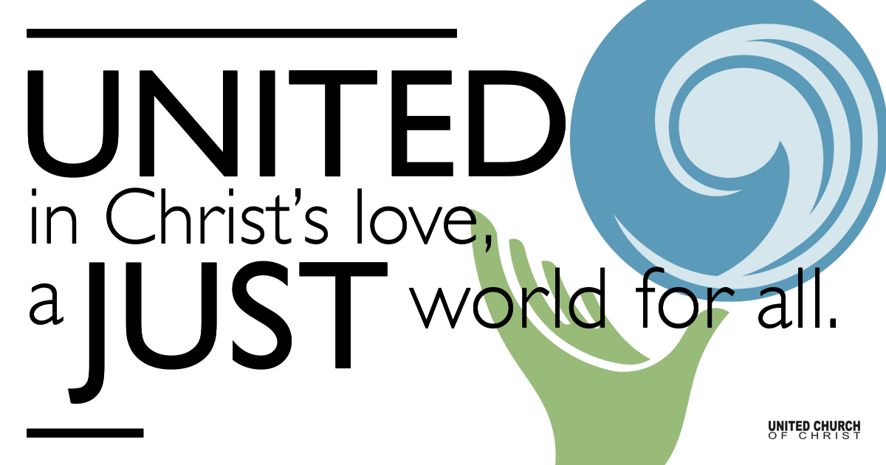
Silent Meditation

March 19, 2023
Fourth Sunday in Lent
Light for the World
“After all, the true seeing is within.” - George Eliot (Mary Ann Evans)

Prelude & Entrance of Light “What Wondrous Love is This” NCH#223

Welcome to Worship
One: Whoever you are and wherever you are on life’s journey,
ALL: We welcome you here.

Opening Comments & Invitation to Sunday School

Announcements

Ringing of the Bell

Call to Worship (based on Ps 23, adapted from the Church of Scotland)
One: We gather together, heeding the call of our God and shepherd,
to come and dwell together.
All: God of love, may we know your goodness and mercy.
One: We gather together, seeking green pastures and still waters,
seeking comfort on difficult journeys through dark valleys.
All: God of love, Restore our souls.
One We gather together, seeking truth, goodness and righteousness.
Teach us what is pleasing to you, O God.
All: God of justice, shine your light upon us.

Prayer for Transformation

Moment of Silent Reflection

Words of Grace

↑Passing of the Peace

↑Centering Song “Enter My Heart” SPP#39

Prayer for Illumination (Reader)

First Reading
(“Where Does the Temple Begin, Where Does It End?” by Mary Oliver)

Second Reading (Ephesians 5:8-14, NRSV)
For once you were darkness, but now in the Lord you are light. Live as children of light -
for the fruit of the light is found in all that is good and right and true.
Try to find out what is pleasing to the Lord.
Take no part in the unfruitful works of darkness, but instead expose them.
For it is shameful even to mention what such people do secretly;
but everything exposed by the light becomes visible,
for everything that becomes visible is light. Therefore it says, "Sleeper, awake! Rise from the dead, and Christ will shine on you."

Reflection Rev. Brent Gundlah

Call to Offering

OGHS Video

Offering Song “Grateful” SPP# 143 (Tom Tomaszek)

↑Doxology & Joyful Return
Praise God from whom all blessings flow
Praise God all creatures here below
Praise God for all that love has done
Creator, Christ, and Spirit One. Amen.

Prayer of Dedication

Children’s Chat & Blessing Rev. Chelsea Page

Many: God of worship wings, we pray for everyone who is overwhelmed by sorrow. May our worship help us to become like swans of joy in a broken-hearted world. Amen.

(Prayer adapted from the Salt Project)

Prayers of the Community
(If you would like to offer a prayer of gratitude or concern for someone or some situation please use first names for security. The congregation will respond to each prayerful offering with the following words:
“Together with God, we hear your prayers.”)

Pastoral Prayer

Jesus Prayer

Words of Mission and Benediction

Closing Song “Hush!” SPP#30

Find out More!



holladayucc.org

Scan to Give & Connect with Us


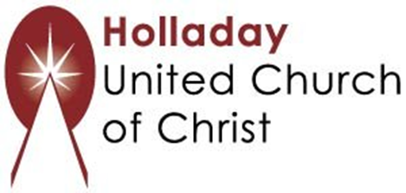
2631 East Murray-Holladay Rd
Holladay, UT 84117 801-277-2631
Rev. Brent Gundlah, Senior Pastor
Rev. Chelsea Page, Associate Pastor

We are a Creation Justice,
Open and Affirming Congregation
of the United Church of Christ.
Participants in Worship:
Reader: Tim Wirkus, Slides: Martha Bale, Video: Roger Lamoni
Sound: Connie Nomann, Music: Holy House Band
Children’s Chat: Rev. Chelsea Page

Welcome visitors! We are glad you are here. Please join us immediately after the service (downstairs in Mac Hall) for coffee and treats.
Parents, Sunday School for ages 4 to 11 will begin after the prelude and children will return after the sermon. We also have free childcare for ages 0-3 in our nursery, next to the gender neutral bathroom.

Upcoming Events
Monday Meditation Group meets online Monday, March 20th at 7 pm in the Chapel.
Progressive Christianity Discussion Group meets on Monday, March 27th at 7 pm in the Chapel and online.
Wednesday evenings in March: Lenten Soups at 6:00 followed by Lenten Services.
Prayer Shawl meets Wednesday, April 5th at 1:00 pm.
HUCC Choir rehearses Wednesdays, April 5th and 12th at 7 pm.

